RESEARCH METHODOLOGY
DESIGN AND DEVELOPMENT REPORT
Explainable AI for Short-Term Wind-Power Forecasting:
Evaluating SHAP Explanation Stability Across Wind Regimes and Temporal Periods

Ruwan Wijayasundara
Faculty of Applied Sciences
Wayamba University of Sri Lanka
15 October 2026

Table of Content
Chapter 1 - Introduction 4
1.1 Background of the Research 4
1.2 Research Context 4
1.3 Research Problem 4
1.4 Research Aim and Objectives 4
1.5 Research Questions 5
1.6 Scope of the Research Methodology 5
1.7 Purpose of the Methodology Design and Development 5
1.8 Structure of the Report 5
Chapter 2 - Literature-Based Methodological Foundation 6
2.1 Introduction 6
2.2 Overview of Relevant Research 6
2.3 Existing Methodologies and Approaches 6
2.4 Comparison of Existing Methods 7
2.5 Strengths and Limitations of Existing Approaches 8
2.6 Research Gaps Relevant to Methodology Development 9
2.7 Methodological Requirements Derived from the Literature 9
2.8 Justification for the Proposed Methodology 10
2.9 Chapter Summary 10
Chapter 3 - Research Design 11
3.1 Research Approach 11
3.2 Research Type and Strategy 11
3.3 Overall Research Design 11
3.4 Selection of Research Methods 11
3.5 Justification for the Research Design 11
3.6 Alignment Between Objectives and Methods 12
3.7 Overall Research Process 12
3.8 Chapter Summary 13
Chapter 4 - Proposed Research Methodological Framework 14
4.1 Overview of the Proposed Framework 14
4.2 Conceptual Framework 14
4.3 Methodological Architecture 14
4.4 Main Components and Their Functions 16
4.5 Relationships Between Components 16
4.6 Methodological Workflow 17
4.7 Inputs, Processes, Outputs, and Dependencies 17
4.8 Mapping of Components to Research Objectives 18
4.9 Justification for the Framework 21
4.10 Chapter Summary 21
Chapter 5 - Methodology Design and Development Process 22
5.1 Requirements Identification 22
5.2 Method Selection Criteria 22
5.3 Design Principles and Assumptions 22
5.4 Design of Methodological Components 22
5.5 Development of Individual Components 23
5.6 Integration of Components 23
5.7 Development of the End-to-End Workflow 23
5.8 Preliminary Testing or Pilot Evaluation 24
5.9 Iterative Refinement 24
5.10 Final Methodology Specification 24
Chapter 6 - Data Collection and Preparation 25
6.1 Data Requirements 25
6.2 Data Sources and Acquisition 25
6.3 Dataset and Sample Selection Criteria 25
6.4 Data Collection and Processing Pipeline 25
6.5 Data Quality Assessment 26
6.6 Cleaning, Missing Values, and Outliers 26
6.7 Feature Engineering and Selection 27
6.8 Data Transformation and Normalization 27
6.9 Data Partitioning and Leakage Prevention 27
6.10 Data Privacy and Management 28
Chapter 7 - Proposed Methods, Models, and Techniques 29
7.1 Overview of the Proposed Approach 29
7.2 Candidate Methods and Algorithms 29
7.2.1 Linear Regression baseline 29
7.2.2 XGBoost 29
7.2.3 Long Short-Term Memory 29
7.3 Selection Criteria 30
7.4 Justification for the Selected Methods 30
7.5 Model Architecture and Feature Representation 30
7.6 Mathematical Foundations and Operational Measures 30
7.7 Baseline Methods for Comparison 31
7.8 Training, Optimization, and Analytical Procedures 31
7.9 Explainability and Interpretability 31
7.10 Expected Outputs 31
Chapter 8 - Computational Architecture and Implementation Design 32
8.1 System Overview 32
8.2 Component and Module Design 32
8.3 Data Flow and Processing Architecture 32
8.4 Model and Analytical Integration 33
8.5 Storage Design 33
8.6 Software and Hardware Requirements 33
8.7 Technology Selection and Justification 33
8.8 Implementation Procedures 33
8.9 Reliability and Deployment Considerations 33
Chapter 9 - Experimental Design and Evaluation 34
9.1 Evaluation Objectives 34
9.2 Experimental Design 34
9.3 Experimental Environment 34
9.4 Evaluation Data and Conditions 34
9.5 Baseline Selection 35
9.6 Evaluation Metrics 35
9.7 Validation Procedures 35
9.8 Statistical Analysis 36
9.9 Robustness and Sensitivity Analysis 36
9.10 Reproducibility Measures 36
9.11 Success Criteria 36
Chapter 10 - Verification, Validation, and Refinement 37
10.1 Verification Strategy 37
10.2 Validation Strategy 37
10.3 Preliminary Testing or Pilot Studies 38
10.4 Comparison with Existing Approaches 38
10.5 Error and Failure Analysis 38
10.6 Robustness Assessment 38
10.7 Identification of Methodological Weaknesses 39
10.8 Refinement and Improvement Procedures 39
10.9 Final Validation Criteria 39
Chapter 11 - Ethical Considerations and Data Management 40
11.1 Ethical Requirements 40
11.2 Privacy and Confidentiality 40
11.3 Consent and Permissions 40
11.4 Research Approvals 40
11.5 Data Storage and Security 40
11.6 Bias, Fairness, and Responsible Use 40
11.7 Data Retention and Sharing 40
Chapter 12 - Expected Outcomes and Research Contributions 41
12.1 Expected Methodological Outcomes 41
12.2 Expected Technical or Analytical Outcomes 41
12.3 Expected Research Contributions 41
12.4 Expected Improvements Over Existing Approaches 41
12.5 Contributions to Individual Objectives 41
12.6 Potential Practical Applications 41
Chapter 13 - Limitations, Risks, and Mitigation 42
13.1 Methodological Limitations 42
13.2 Data or Evidence Limitations 42
13.3 Technical Constraints 42
13.4 Resource Constraints 42
13.5 Potential Sources of Bias 42
13.6 Development and Implementation Risks 43
13.7 Risk Mitigation Strategies 44
13.8 Assumptions and Dependencies 44
Chapter 14 - Work Plan and Resources 45
14.1 Research and Development Activities 45
14.2 Development Stages and Milestones 45
14.3 Project Timeline 46
14.4 Hardware and Software Requirements 47
14.5 Personnel and Expertise 47
14.6 Budget 47
14.7 Expected Deliverables 47
Chapter 15 - Conclusion 48
References 49

Table of Figures
Figure 1:Overall Research Methodology Flowchart 13
Figure 2:Research Conceptual Framework 14
Figure 3: Proposed Research Methodological Framework 15
Figure 4:Methodology Design and Development Lifecycle 24
Figure 5:Data Collection and Processing Pipeline. 26
Figure 6:File-Based Computational Architecture 32
Figure 7:Experimental Design and Evaluation Workflow 34
Figure 8:Verification, Validation, and Refinement Framework 37
Figure 9:Indicative 20-Week Research Development Timeline 47

Table of Tables
Table 1:Comparison of methods and evidence relevant to the proposed study 7
Table 2:Methodological requirements derived from the literature 9
Table 3: Alignment of the research objectives and methods 12
Table 4:Methodological component register 16
Table 5:Input–process–output dependencies 17
Table 6:Objective traceability matrix 18
Table 7:Methodology development stages 23
Table 8:Candidate data channels and availability controls 27
Table 9:Core model specification 29
Table 10:Evaluation measures and interpretation 35
Table 11:Verification and validation evidence plan 38
Table 12:Objective-specific expected outcomes 41
Table 13:Risks and mitigation actions 43
Table 14:Indicative milestones, dependencies, and deliverables 45

Introduction

Background of the Research
Wind generation varies with meteorological conditions and turbine operating states. Short-horizon forecasts can support operational planning, but a forecast-error score alone does not show which inputs contributed to a prediction or whether those attributions repeat across operating conditions and time. The supplied proposal therefore links two outcomes: predictive performance and the stability/reliability of SHAP explanations. The methodology treats SHAP as a model-attribution method, not as evidence of physical causation.

Research Context
The study is a computational analysis of secondary, public, time-stamped turbine SCADA data and any verified meteorological/operational channels. The primary site is Kelmarsh, a six-turbine, 10-minute SCADA release. The 2023–2024 source files require a provenance and reconstruction check using the Park deposit, signal-onset manifest, and flags. Penmanshiel is a conditional second-site test; SDWPF is not part of the core design. The working title used in this report is the title stated as proposed in the research proposal and used by the literature review.

Research Problem
The central problem is insufficient focused, reproducible evidence about how SHAP attributions for short-term wind-power forecasts vary between predefined wind regimes, how repeatable they are across chronological windows within comparable conditions and repeated fits, and whether forecast accuracy aligns with explanation stability. The literature already contains wind-specific SHAP and XAI work, trustworthiness evaluation, temporal explanation methods, and comparator forecasting studies. The study therefore does not claim a general absence of XAI or stability research.

Research Aim and Objectives
Main objective (verbatim): To evaluate short-term wind-power forecasting performance and quantify the stability of SHAP explanations across wind regimes and chronological test periods using a reproducible, data-audited experimental design.
Specific objectives (verbatim from the supplied proposal):
- Audit and prepare the selected multivariate SCADA dataset, documenting signal availability, data-quality decisions, temporal coverage, and forecast-time feature availability.
- Develop and compare a consistent core set of forecasting models: Linear Regression, XGBoost, and LSTM, for 10-minute-ahead turbine active-power prediction.
- Apply SHAP to generate global feature summaries and local explanations for held-out forecasts using documented model-appropriate explainers and reference data.
- Measure explanation stability across low-, medium-, and high-wind-speed regimes and across chronological evaluation windows using pre-specified quantitative measures.
- Evaluate forecasting errors and explanation behaviour jointly, including a cautious assessment of whether better forecast accuracy coincides with more stable explanations.

Research Questions
- RQ1: How accurately can Linear Regression, XGBoost, and LSTM forecast turbine active power 10 minutes ahead using multivariate SCADA and available meteorological inputs?
- RQ2: Which input features receive the largest global and local SHAP attributions in the selected forecasting models?
- RQ3: How do SHAP feature attributions differ among predefined low-, medium-, and high-wind-speed regimes?
- RQ4: Within each wind-speed regime, how stable are SHAP feature rankings and attribution magnitudes across chronological test windows and repeated model fits?
- RQ5: How do forecast performance and explanation-stability measures relate across the selected models and evaluation conditions, and does the model with the best forecast accuracy also have the most stable explanations?

Scope of the Research Methodology
- Core prediction: turbine active power at t+1 on a 10-minute sampling interval; the primary claim is limited to this horizon.
- Core data: Kelmarsh v4, subject to actual file inspection and the 2023–2024 reconstruction audit; unit of analysis is a turbine-time forecast.
- Core model set: LR baseline, XGBoost, and LSTM. Random Forest is not included in the core comparison.
- Core evaluation: MAE, RMSE, supplementary R², global/local SHAP, regime contrasts, within-regime temporal stability, repeated-fit sensitivity where feasible, and a limited perturbation/ablation check.
- Penmanshiel is conditional external site-transfer evidence only if target, feature, and coverage harmonization is defensible. SDWPF, new turbine measurement collection, causal inference, human-subject trust studies, novel architectures, day-ahead forecasts, and deployment are outside the core scope.

Purpose of the Methodology Design and Development
This report translates the source-defined objectives into a feasible, leakage-safe, auditable workflow. It states which decisions are fixed by the proposal and which must be selected during the training/validation phase; specifies how each component will be developed, integrated, verified, validated, and refined; and maps every objective to inputs, procedures, evaluation evidence, and outputs. It is a plan, not a record of completed implementation.

Structure of the Report
- Chapters 2–4 - Establish the literature-based rationale, research design, and integrated framework.
- Chapters 5–8 - Specify development, data preparation, methods, and computational architecture.
- Chapters 9–10 - Define experimental evaluation and verification/validation.
- Chapters 11–14 - Address ethics, expected outcomes, risks, and resources.
- Chapter 15 - Concludes; the appendices provide implementation pseudocode and source-file guidance.

Literature-Based Methodological Foundation

Introduction
The literature review supports a bounded experimental contribution rather than an algorithm-invention claim. This chapter draws methods from recent wind-power forecasting surveys, selected forecasting comparisons, wind-specific XAI studies, time-series explanation-evaluation research, and public dataset/provenance evidence. Reference numbers in this report follow the 40-item IEEE list in the supplied literature review.

Overview of Relevant Research
Recent forecasting surveys describe statistical, machine-learning, deep-learning, hybrid, decomposition, and attention-based approaches and emphasize that comparisons depend on horizon, scale, inputs, preprocessing, and validation design [1]–[10]. A wind-power metric review supports reporting complementary errors and stating target scale [11]. Wind-focused method studies include XGBoost optimization, recurrent/LSTM forecasting, and temporal convolution [12]–[14]. Dataset and provenance evidence concerns Kelmarsh v4, reconstructed 2023–2024 files, Penmanshiel, SDWPF, and cross-site portability [15]–[19]. Recent comparators include Transformers, integrated boosting, missing-data reconstruction, and turbine-level chronological comparisons [20]–[23].
Wind-specific explainability is established. Studies apply SHAP to turbine and farm power predictions, investigate meteorological attributions, assess trustworthiness, offer glass-box alternatives, extend to LSTM or hybrid models, and review broader wind-energy XAI [24]–[33]. General time-series XAI research contributes taxonomies, quantitative explanation-evaluation concepts, stability/robustness measures, window-based attribution, and cautions about perturbation design [34]–[40]. These methods are relevant but must be adapted cautiously because some were developed for classification or non-wind domains.

Existing Methodologies and Approaches
- Forecast comparison: Choose a transparent linear reference, a boosted-tree learner for structured SCADA features, and an LSTM sequence learner; train and compare on identical target timestamps. Wind-specific XGBoost/LSTM studies support the relevance of these families without determining which will perform best on Kelmarsh [12], [13].
- Chronological evaluation: Preserve time order, use training-only preprocessing, select model settings on the validation year, and reserve 2024 for final evaluation. A turbine-level 10-minute comparator shows the relevance of lag features and chronological splitting, but does not answer the joint SHAP stability questions [23].
- XAI: Use SHAP to summarize global feature contributions and selected local predictions, with a documented explainer, feature mapping, and background/reference sample. Wind-power studies demonstrate prior use; attribution is conditional on the model and explanation setup [24]–[33].
- Stability: Compare feature-rank agreement across chronological windows within each wind regime; use top-k overlap and attribution dispersion as secondary summaries; distinguish regime dependence, temporal variation, and stochastic fit variation [35]–[40].
- Faithfulness/reliance checks: Perturb or ablate pre-specified groups using plausible replacements, because arbitrary masking can create unrealistic inputs. Interpret this as a model-reliance check, not causality [37], [40].
- Dataset governance: Preserve source releases, audit flags, onset manifests, timestamp reconstruction, and site differences; report external-site findings separately rather than pooling incompatible data [15]–[19]

Comparison of Existing Methods
Table 1:Comparison of methods and evidence relevant to the proposed study
Study / evidence | Method | Data or inputs described | Evaluation approach described | Limitations relevant here | Relevance to this study
Xiong et al. [12] | Wind-power XGBoost with hyperparameter optimization. | Structured wind-power predictors; exact candidate inputs depend on that study. | Forecasting accuracy under the study-specific design. | Different site, horizon, features, and validation mean its score is not a transferable benchmark. | Supports XGBoost as a candidate; current study must tune only on 2023 and test on 2024.
Li et al. [13]; Sheng et al. [14] | LSTM/recurrent and temporal-convolution approaches. | Sequential wind-power inputs and study-specific covariates. | Short-term prediction comparisons. | Architectures and data protocols differ; model-family results do not define the best local model. | Justifies a sequence-model comparator while keeping the forecast target fixed.
Huang et al. [20]; Ahmed et al. [21] | Transformer-based forecasting and integrated boosting. | Multivariate wind-power/time-series inputs. | Study-specific error comparisons. | Different architecture, horizon, and dataset; not an apples-to-apples ranking for Kelmarsh. | Positions LR/XGBoost/LSTM comparison within a broader evolving field.
Xin et al. [22] | LSTM with missing-data reconstruction. | Wind-power sequence data with missing values. | Forecast comparison after a reconstruction method. | Reconstruction choices may affect both error and explanation; local handling must be audited. | Motivates explicit missingness/provenance controls before explanation.
Demir and Akkaya Oy [23] | Turbine-level lag-based ML comparison. | 10-minute turbine data with lag/rolling features. | Chronological split and model comparisons including linear and boosted methods. | A close accuracy comparator; it does not establish the proposed regime-by-time SHAP assessment. | Prevents unsupported “first turbine-level 10-minute comparison” framing.
Cakiroglu et al. [24]; Kim and Kim [25]; Liao et al. [26]; Yassen et al. [28] | Wind-specific SHAP/XAI for ensemble, meteorological, trustworthiness, and LSTM settings. | Turbine/farm power models and associated SCADA or meteorological features. | Global/local explanations; Liao et al. include quantitative trustworthiness measures. | Explanation settings, feature dependence, and evaluation conditions vary; an attribution plot alone is not stability evidence. | Supports SHAP as established; directs this study to specify background and quantify stability.
Dandamudi et al. [29]; Matrenin et al. [30]; wind/time-series studies [31]–[33] | Domain/system reviews; TimeSHAP; multivariate/deep and hybrid XAI. | Wind forecasting and renewable-energy systems; sequence inputs in temporal work. | Review synthesis, temporal explanation, repeated training, or uncertainty-aware analyses. | Temporal explanation and system trust remain distinct; repeated model accuracy is not by itself attribution stability. | Motivates a narrow, auditable combination of wind regimes, chronology, and matched forecast errors.
Time-series XAI evaluation [34]–[40] | Stability, quantitative evaluation, window/group explanations, and meaningful perturbation methods. | Mostly general time-series, classification, or non-wind settings. | Rank/robustness metrics, task-based evaluation, perturbations, and window-based attribution. | Measures are not automatically validated for wind-power regression; masking may be out of distribution. | Use a pre-specified adaptation and cautious, continuous interpretation.
Kelmarsh / Park / Penmanshiel / SDWPF / portability [15]–[19] | Open SCADA releases, reconstructed/audit deposit, and cross-site calibration evidence. | 10-minute multi-turbine site data; channel coverage varies by release/site. | Dataset or cross-site forecasting assessment. | Exact signal coverage and source-file integrity must be confirmed; sites are not interchangeable. | Requires data-lineage audit, common features, and separate conditional transfer reporting.

Strengths and Limitations of Existing Approaches
The literature provides suitable forecasting model families, wind-specific SHAP precedents, quantitative explanation-quality concepts, and public multi-turbine datasets [12]–[40]. It also provides reasons not to overclaim: study-specific horizons and splits limit score transfer; correlated SCADA features can redistribute attributions; model-appropriate explainers and background data affect results; stability, faithfulness, and causal truth are not interchangeable; and cross-site transfer is not broad generalization [19], [26], [29], [35]–[40].

Research Gaps Relevant to Methodology Development
The relevant gap is not the absence of SHAP or stability research. It is the need for a single, reproducible experiment that audits source data and forecast-time availability; evaluates accuracy on common chronological observations; compares explanations across predefined wind regimes; tests repeatability across chronological windows within each regime and across repeated fits; and relates the accuracy and stability evidence without assuming a direction [24]–[40].

Methodological Requirements Derived from the Literature
Table 2:Methodological requirements derived from the literature
Requirement | Evidence motivating it | Design response | Verification evidence
R1. Provenance before modeling | Kelmarsh 2023–2024 reconstruction and signal-onset concerns [15], [16]. | Preserve original and reconstructed files; manifest versions, hashes, flags, timestamps and exclusions. | Reconstruction reproduction/check; row counts, timestamp uniqueness, coverage report.
R2. Forecast-time feature eligibility | SCADA signals can be unavailable at issue time; later values leak the target [15]–[17]. | Use only signals available by issue time; all other measurements enter as lags or are excluded. | Feature-timestamp audit and automated no-future-data tests.
R3. Comparable forecasting evaluation | Metric choice and protocol influence interpretation [11], [23]. | Common t+1 target and timestamps; chronological train/validation/test; MAE/RMSE plus R². | Identical scored row IDs across models; metric code tests.
R4. Explanation configuration transparency | Wind XAI and SHAP depend on model, background, and feature dependence [26], [29], [32]. | Record explainer, reference sample, feature map, aggregation, software version and seeds. | SHAP additivity/output checks and background sensitivity report.
R5. Separate condition dependence from instability | Stability and time-series XAI literature distinguishes quality dimensions [35]–[40]. | Compare regimes descriptively; quantify temporal repeatability only within the same regime. | Tables report regimes and windows separately; no universal binary threshold.
R6. Plausible faithfulness check | Unrealistic perturbations can mislead [37], [40]. | Use pre-specified grouped perturbations with plausible conditional replacements. | Input plausibility checks and high-vs-control group comparison.
R7. Reproducibility and scope control | Open data and cross-site evidence vary in coverage and context [15]–[19]. | Freeze protocol, preserve code/config/logs, and keep Penmanshiel separate and conditional. | Independent rerun from manifest; separate site-transfer report.

Justification for the Proposed Methodology
A retrospective quantitative computational experiment directly answers the proposal’s questions because the outcomes are numerical forecasts, feature attributions, stability statistics, and matched error summaries. A common chronological design addresses the temporal structure of the data; model diversity supports the requested comparison; SHAP is justified by established wind-specific applications; and within-regime stability metrics target the bounded gap. Provenance checks are not optional preprocessing: they protect the validity of both forecasts and explanations [11], [15], [16], [24]–[40].

Chapter Summary
The literature justifies a time-aware, data-audited, multi-model comparison with explicit SHAP configuration and separate tests of regime dependence, temporal stability, fit sensitivity, and model reliance. It does not predetermine results or support causal or universal-trust claims.

Research Design

Research Approach
The approach is quantitative and empirical. It analyzes historical, secondary SCADA records, fits forecasting models, and computes numerical forecast and explanation measures. There is no intervention in turbine operation and no qualitative or human-subject component in the core study.

Research Type and Strategy
The research is an applied, retrospective, comparative computational experiment. The experimental factors are model family, wind regime, chronological test window, and—where feasible—training seed. The primary site is held fixed to reduce cross-study and cross-site variation; Penmanshiel is a separately reported optional transfer test.

Overall Research Design
The target is the active-power measurement at the next 10-minute observation, P(t+1), conditional on information available at the forecast origin t. The supplied proposal specifies chronological training (2017–2022), validation (2023), and final testing (2024). Transformations, input selection, lookback, thresholds, and hyperparameters are selected without using the final test year. The core model comparison uses LR, XGBoost, and LSTM on matched eligible rows; global/local SHAP and stability analysis follow on the same final-test cases.

Selection of Research Methods
The method selection follows four criteria:
- Direct mapping to each original objective and RQ;
- Temporal and forecast-time validity;
- Comparability across models;
- Feasibility with the specified data and computational scope.
LR provides a transparent baseline; XGBoost represents structured nonlinear boosting; LSTM represents sequence modeling. SHAP and the stability metrics are selected because they are specified in the proposal and connected to the literature review [12], [13], [24]–[40].

Justification for the Research Design
Randomly shuffling turbine-time records would expose the evaluation to temporal leakage and would not represent the stated future-forecast task. A fixed chronological holdout, common rows, training-only preprocessing, and a locked 2024 test directly address the proposed research purpose. The design is not intended to prove physical causation or universal model superiority; it produces dataset-, horizon-, and protocol-specific evidence.

Alignment Between Objectives and Methods
Table 3: Alignment of the research objectives and methods
Objective | Core method | Primary evidence | Report sections / figures
O1. Audit and prepare data | Provenance, signal, time, quality and forecast-time audit; leakage-safe feature pipeline. | Manifest, coverage/QC reports, valid target-row list, no-lookahead tests. | Ch. 5–6; F5; traceability Table 8.
O2. Compare LR, XGBoost, LSTM | Common target and time split; model-specific representation; validation-only tuning. | MAE, RMSE, R² on common 2024 rows, overall and by turbine/regime. | Ch. 7, 9; F3, F7.
O3. Apply SHAP | Global/local model-appropriate explanations with fixed feature map/reference. | Global and local attributions; configuration and sensitivity logs. | Ch. 7, 9; F2, F3, F6.
O4. Measure stability | Regime contrasts; within-regime window comparisons; fit-seed sensitivity. | Spearman rank, top-five Jaccard, normalized dispersion and uncertainty. | Ch. 7, 9; F2, F3, F7.
O5. Joint evaluation | Paired accuracy–stability analysis and limited plausible perturbation check. | Matched error/stability profiles, exploratory association, bounded interpretation. | Ch. 9–10; F7–F8.

Overall Research Process
Figure 1 summarizes the complete progression from the bounded problem and proposal objectives to audited data, model comparison, forecast and SHAP outputs, regime/time analysis, verification, validation, refinement, and reporting. The workflow places data quality and forecast-time availability before model fitting and routes both error and explanation evidence into the joint interpretation.
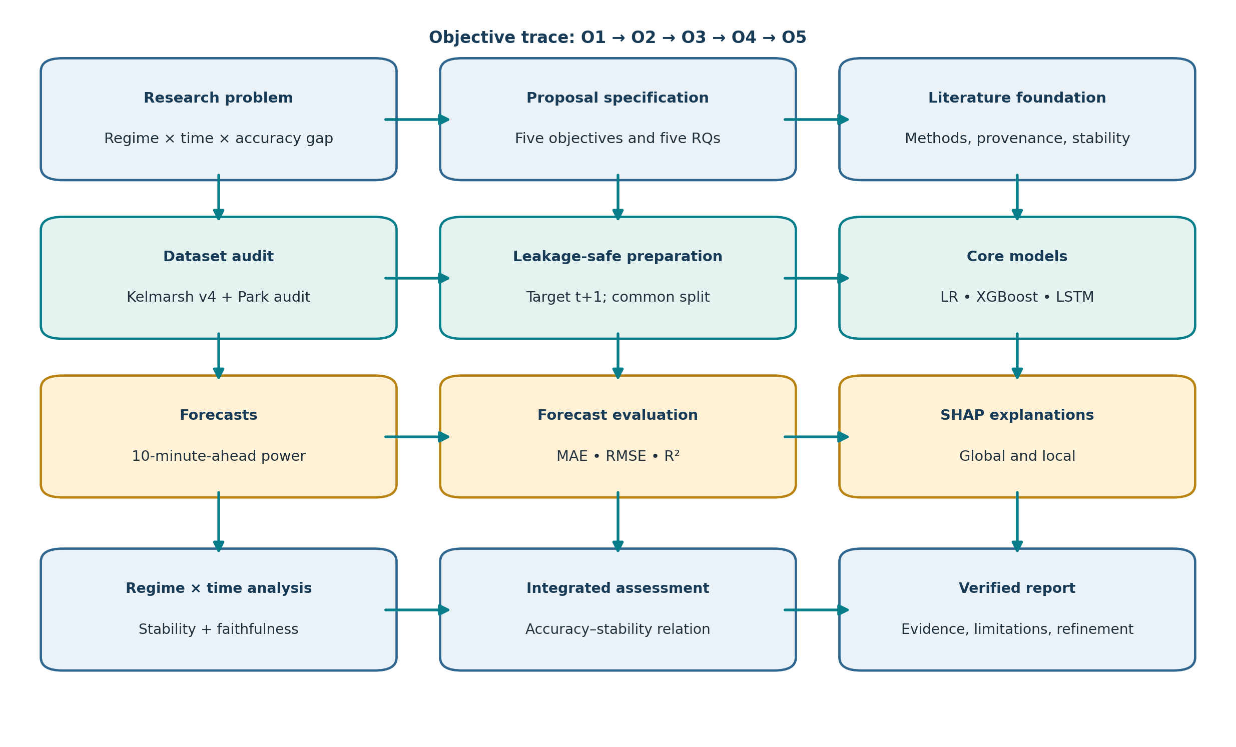
Figure 1:Overall Research Methodology Flowchart
The flowchart traces O1 through O5: data audit and preparation enable the model comparison; matched forecasts support both accuracy and SHAP analysis; regime/time evaluation feeds the integrated accuracy–stability question; verification and validation can trigger revision. It is a planned process, not a record of completed experiments.

Chapter Summary
A quantitative retrospective computational experiment is appropriate because the objectives require numerical prediction, explanation, and stability evidence. The fixed time split, common scoring rows, and planned verification gates make the research questions testable while preserving the stated non-causal scope.

Proposed Research Methodological Framework

Overview of the Proposed Framework
The framework joins data provenance, predictive modeling, explainability, stability evaluation, and integrated interpretation under one fixed forecast target and common evaluation timestamps. Its output is an auditable protocol and, after execution, dataset-specific empirical evidence. It does not create a new model architecture.

Conceptual Framework
The conceptual framework distinguishes inputs, analytical mechanisms, outcomes, and influences. The observed input data pass through an availability and preparation process; LR, XGBoost, and LSTM generate forecasts; forecast errors and SHAP contributions are measured; wind regime and chronological window condition the comparison. Seasonality, operational events, missingness, correlated features, seeds, and the SHAP background are documented influences rather than presumed causes.
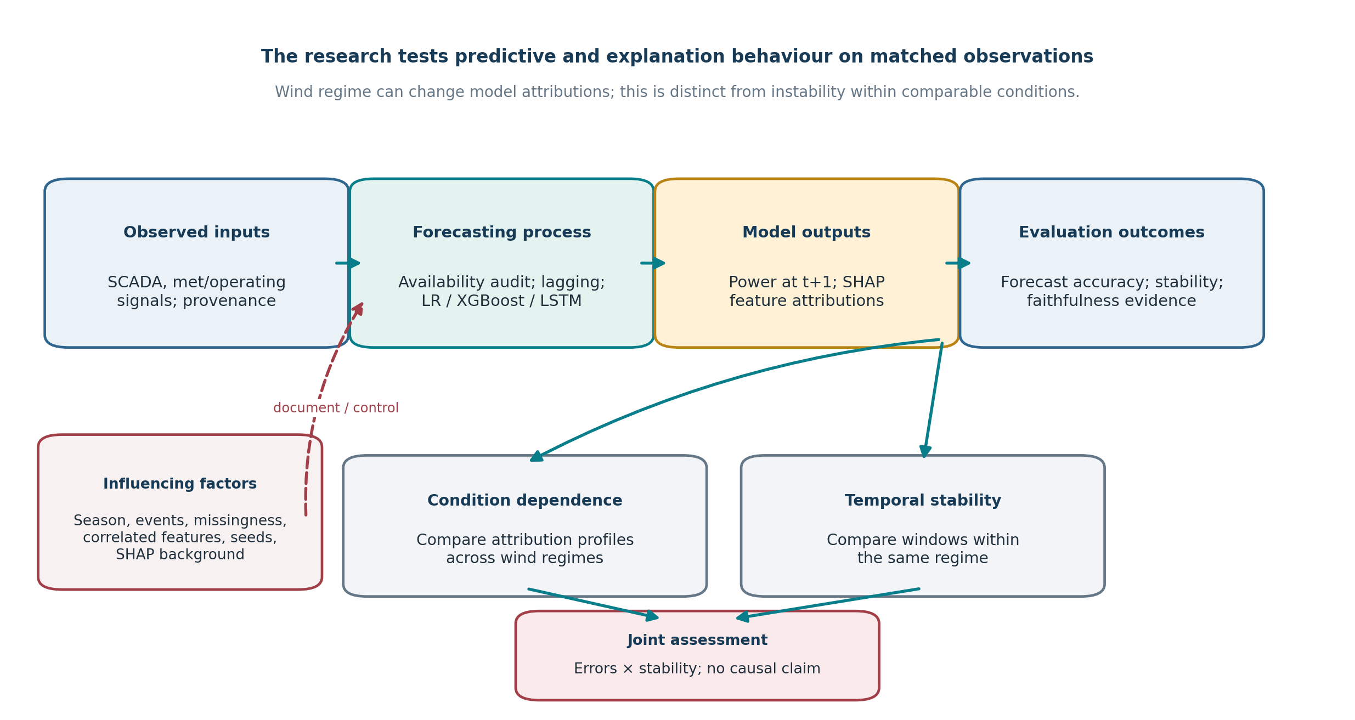
Figure 2:Research Conceptual Framework
Figure 2 connects the proposal’s variables and evaluation dimensions. O1 governs input validity; O2 produces the forecasts; O3 generates attributions; O4 evaluates regime and time variation; O5 combines error and stability evidence. A between-regime attribution difference is condition dependence, not automatically instability, and neither outcome establishes physical causation.

Methodological Architecture
The architecture has five linked layers:
(1) Source acquisition and provenance;
(2) Temporal/quality audit and feature construction;
(3) Comparable model fitting and prediction;
(4) SHAP, regime, window, seed, and perturbation analysis;
(5) ntegrated evaluation, verification, and reporting.
The common target and feature-group map are interface contracts between these layers.
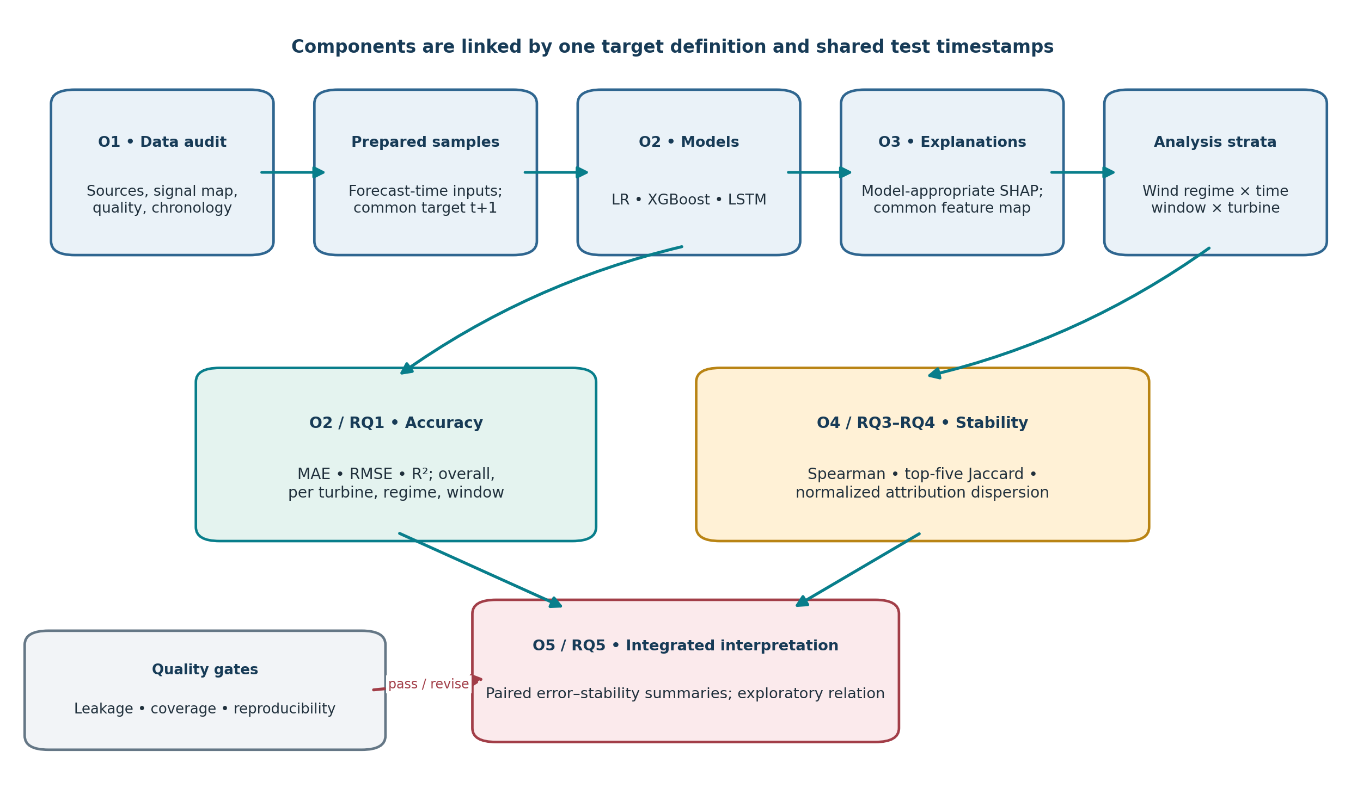
Figure 3: Proposed Research Methodological Framework
Figure 3 names each component by the objective and question it serves;
- O1 supplies valid rows;
- O2 yields comparable forecasts;
- O3 explains those forecasts;
- O4 quantifies stability;
- O5 integrates paired accuracy and explanation evidence.
Shared test observations, one feature map, and frozen analysis choices reduce avoidable comparison differences.

Main Components and Their Functions
Table 4:Methodological component register
Component | Purpose and inputs | Activities / methods | Output and dependency | Objective
C1. Provenance and data gate | Kelmarsh raw release; audit deposit; metadata; event/status logs. | Version, hash, schema, timestamp, signal-onset, duplicates, units and coverage audit. | Approved source manifest; must pass before features/models. | O1
C2. Feature and split builder | Audited measurements and target definition. | Forecast-time eligibility, lagging, feature groups, regime signal, chronological split. | Matched train/validation/test samples; depends on C1. | O1
C3. Model bench | Analysis-ready samples and frozen configuration. | LR, XGBoost, LSTM fitting; validation-only tuning; common test scoring. | Predictions and errors; depends on C2. | O2
C4. Explanation layer | Fitted models, test cases, background sample, feature map. | Global/local SHAP; sequence-to-feature aggregation; sensitivity checks. | Attributions; depends on C3 and C2. | O3
C5. Stability/reliance layer | Attributions, regimes, windows, seeds, perturbation groups. | Spearman, top-five Jaccard, dispersion; plausible group perturbation. | Stability and reliance evidence; depends on C4. | O4
C6. Integrated evidence layer | Errors, explanations, stability metrics, uncertainty. | Matched comparisons, block resampling, interpretation matrix, risk review. | Objective-linked conclusions and reproducibility bundle. | O5

Relationships Between Components
C1 controls whether the data are trustworthy enough to model. C2 creates one time-valid target and input representation. C3 establishes forecast behavior; C4 explains the same fitted models and test cases. C5 distinguishes changes across different regimes from instability within a regime and separates seed sensitivity from temporal variation. C6 joins the evidence without allowing a favorable accuracy score to substitute for explanation stability, or vice versa

Methodological Workflow
- Freeze the target, split, candidate channels, regime signal, and decision rules before final test evaluation.
- Acquire and preserve the raw data; reconcile 2023–2024 files and audit timestamp, signal, quality, and coverage information.
- Construct analysis samples without crossing turbine boundaries or data gaps; fit preprocessing on training data only.
- Train/tune LR, XGBoost, and LSTM using 2017–2022 and 2023 validation; freeze the configuration, then evaluate the reserved 2024 year.
- Generate global/local SHAP on common cases; compare regimes and fixed chronological windows within regimes; run planned fit/faithfulness sensitivities.
- Verify implementation, validate objective coverage, refine weak components, and report scope-limited findings.

Inputs, Processes, Outputs, and Dependencies
Table 5:Input–process–output dependencies
Input | Process | Output | Dependency / control
Raw SCADA, events, audit deposit, signal map | Preserve, hash, inspect, reconcile | Versioned source manifest and accepted rows | No model development before integrity gate.
Accepted rows, target and eligible channels | Align timestamps, build lags/sequences, freeze regime bands | Model-ready time-indexed samples | No post-issue predictors; no sequence crossing gaps/turbines.
Model-ready samples and config | Fit/tune the LR, XGBoost, and LSTM configurations; final fit remains on 2017–2022 | Common test predictions and residuals | 2024 not used for feature/hyperparameter selection.
Fitted models, reference data and held-out rows | Compute SHAP and grouped summaries | Global/local attribution records | Same feature map and documented background per model.
Attributions, errors, windows, regimes and seeds | Compare rank/overlap/dispersion; perturb plausible groups | Stability, reliance and uncertainty summaries | Condition dependence reported separately from within-regime instability.

Mapping of Components to Research Objectives
Table 6:Objective traceability matrix
Research objective | Supporting literature gap | Methodological component | Required inputs | Development / analytical procedure | Evaluation method | Expected output | Report section / figure
O1. Audit and prepare the selected multivariate SCADA dataset, documenting signal availability, data-quality decisions, temporal coverage, and forecast-time feature availability. | Dataset-specific provenance, signal onset, missingness and test-validity concerns [15]–[19]. | C1 provenance gate + C2 feature/split builder. | Kelmarsh v4; Park reconstructed files/manifest/flags; signal map; events/status; timestamps. | Preserve/version/hash; reconcile duplicate blocks; audit units/onset/coverage; define target and only issue-time-available predictors; fit preprocessing on training data. | Schema and timestamp tests; coverage/missingness report; no-lookahead tests; exact eligible row manifest. | Audited dataset manifest; preprocessing pipeline; documented feature set and exclusions. | §§5–6; F5; F8.
O2. Develop and compare a consistent core set of forecasting models: Linear Regression, XGBoost, and LSTM, for 10-minute-ahead turbine active-power prediction. | Cross-study scores are not comparable when horizons, inputs and splits differ [1]–[14], [20]–[23]. | C3 model bench. | Matched time-safe samples; target P(t+1); development/validation split; model configuration. | Implement LR, XGBoost, LSTM; choose settings only on 2023; freeze and score identical 2024 timestamps; keep sequences within turbines. | MAE, RMSE, R² and paired block uncertainty; overall and by turbine/regime if coverage allows. | Model predictions, error profiles and a reproducible comparison table. | §§3, 7, 9; F3, F6–F7.
O3. Apply SHAP to generate global feature summaries and local explanations for held-out forecasts using documented model-appropriate explainers and reference data. | Wind-specific SHAP exists; explanations depend on explainer/background/features and are not causal [24]–[33]. | C4 explanation layer. | Fitted models, common final-test cases, feature-group map, training-derived background. | Select compatible explainers; document versions/background; aggregate sequence-step contributions to common feature groups; sample local cases by rule. | Check additivity/consistency; compare background sensitivity; inspect global/local outputs on matched cases. | Global rankings, signed attributions and selected local explanations with configuration record. | §§4, 7–9; F2–F3, F6–F7.
O4. Measure explanation stability across low-, medium-, and high-wind-speed regimes and across chronological evaluation windows using pre-specified quantitative measures. | Temporal explanation evaluation and stability methods exist but require careful adaptation [34]–[40]. | C5 stability/reliance layer. | SHAP values, forecast-time wind signal, frozen thresholds, fixed 2024 windows, fit seeds. | Compare regimes as condition dependence; compare windows within each regime; separate seed from temporal changes. | Primary pairwise Spearman; secondary top-five Jaccard and normalized attribution dispersion; block-based uncertainty. | Continuous stability profiles with cell counts and uncertainty; no universal binary label. | §§4, 7, 9–10; F2–F3, F7–F8.
O5. Evaluate forecasting errors and explanation behaviour jointly, including a cautious assessment of whether better forecast accuracy coincides with more stable explanations. | Accuracy and explanation evaluation should not be conflated; faithfulness/stability are distinct [11], [26], [35]–[40]. | C6 integrated evidence layer. | Matched error summaries, stability scores, perturbation outputs, model/regime/window identifiers. | Pair model/window error with within-regime stability; run plausible grouped perturbations; report model-level relation as exploratory. | Paired profiles; exploratory Spearman association; block bootstrap respecting time/turbine; interpretation matrix. | Scope-bounded answer to RQ5 and an auditable evaluation protocol. | §§9–10, 12–15; F1, F3, F7–F8.

Justification for the Framework
The framework is specific to the source-defined 10-minute turbine forecast, audited Kelmarsh data, LR/XGBoost/LSTM comparison, and SHAP stability questions. It uses one time-aware data path and one matched evaluation set to prevent data, split, and feature mismatches from masquerading as model or explanation differences. Each objective has a measurable output and verification evidence.

Chapter Summary
The framework is a connected sequence of data, model, explanation, stability, and synthesis components, with provenance and evaluation controls embedded at the relevant interfaces. Table 8 provides objective-level traceability; Figures 2–3 make the conceptual and procedural relationships explicit.

Methodology Design and Development Process

Requirements Identification
Requirements are derived from the five source objectives, five research questions, and literature gaps: an audited multivariate dataset; issue-time eligibility; common 10-minute target and rows; three specified model families; global and local SHAP; separate regime and temporal comparisons; uncertainty-aware reporting; and reproducible provenance/configuration records. The exact feature list and data thresholds are intentionally deferred until file inspection.

Method Selection Criteria
- Objective fit: Every method must produce evidence for one or more original objectives.
- Temporal validity: Preserve chronological order and forecast-origin availability.
- Comparability: Common target, feature groups, eligible timestamps and evaluation windows.
- Interpretability: Record assumptions, reference data, SHAP aggregation, and limitations.
- Feasibility: Limit models, sites and sensitivity checks to the proposal’s scope and available computation.
- Reproducibility: Preserve source versions, checksums, code, configuration, seeds and output manifests.

Design Principles and Assumptions
- Use the stated Kelmarsh source and split only if the 2023–2024 reconstruction and signal coverage pass audit.
- Assume the 10-minute sampling grid corresponds to t+1 only after verifying timestamps, measurement interval semantics, units and latency.
- Use a common high-level feature map across models where possible; model-specific encodings must be documented.
- Do not infer that a stable attribution is physically true or that a regime difference is instability.
- Treat the proposed pooled-by-site training default as a design recommendation to confirm after pilot; keep sequence construction and reporting turbine-aware.
- Keep the final test set untouched until the protocol is frozen; use training and validation data for all choices.

Design of Methodological Components
Each component has a contract: the data gate emits a versioned, timestamp-valid table; the feature builder emits one target-aligned sample set and group map; the model bench emits predictions on common rows; the explanation layer emits contributions on those same rows; the stability layer emits comparisons grouped by regime/window; and the synthesis layer emits paired evidence with uncertainty and limitations. If a component fails its contract, downstream results are not interpreted until it is correc

Development of Individual Components
Table 7:Methodology development stages
Stage / purpose | Inputs | Activities and proposed tools | Expected output / dependency | Objectives / principal limitation
1. Source audit | Public release; Park reconstruction files; metadata and flags. | Download/read documentation; preserve raw; compute hashes; verify schema, timestamps, onset, duplicates, units, licence and event definitions. | Source manifest and audit report; required before modeling. | O1; actual data not yet inspected.
2. Feature pipeline | Audited observations and target. | Pandas/NumPy-style time alignment; causal lags; train-only imputation/scaling; sequences per turbine; frozen chronological split. | Matched model-ready data and tests. | O1; exact channels/coverage unresolved.
3. Forecast models | Train/validation data and fixed candidates. | Implement ordinary LR, XGBoost, LSTM; validation-only parameter/lookback selection; pin library versions; log seeds. | Three model artifacts and validation decisions. | O2; LSTM runtime and optimal lookback unknown.
4. SHAP adapter | Fitted models, test samples, common feature groups and background. | Pilot compatible Linear/Tree/Deep/Gradient/Permutation explainers; check output agreement/additivity; define sequence aggregation. | Global/local attribution store and configuration record. | O3; LSTM explainer compatibility and cost require pilot.
5. Stability / faithfulness | Attributions, test regimes/windows and candidate groups. | Compute Spearman, top-five Jaccard, normalized dispersion; repeat stochastic fits; use plausible grouped perturbations. | Continuous stability and perturbation summaries. | O4; small cells or correlated inputs may limit interpretation.
6. Integration / evidence | Model errors, SHAP, stability, audit logs. | Join on turbine/time/model; block-based uncertainty; generate tables/plots; verify traceability. | Objective-mapped research evidence and final report. | O5; only three model families make model-level association exploratory.

Integration of Components
Integration is controlled by shared identifiers: turbine, timestamp, target horizon, model, regime, window, and fit seed. A single evaluation-row manifest is used to join forecasts, errors, SHAP values, and stability calculations. Data transformations are fit once on training data and applied unchanged. Each output stores the producing code version and configuration so that an explanation cannot be detached from the model and input representation that generated it.

Development of the End-to-End Workflow
Figure 4 shows the planned development lifecycle. Requirements and method selection precede component design; individual components are then built and integrated; a pilot on training/validation data is followed by verification, validation, and evidence-driven refinement. The final specification is frozen before the 2024 final-test evaluation.
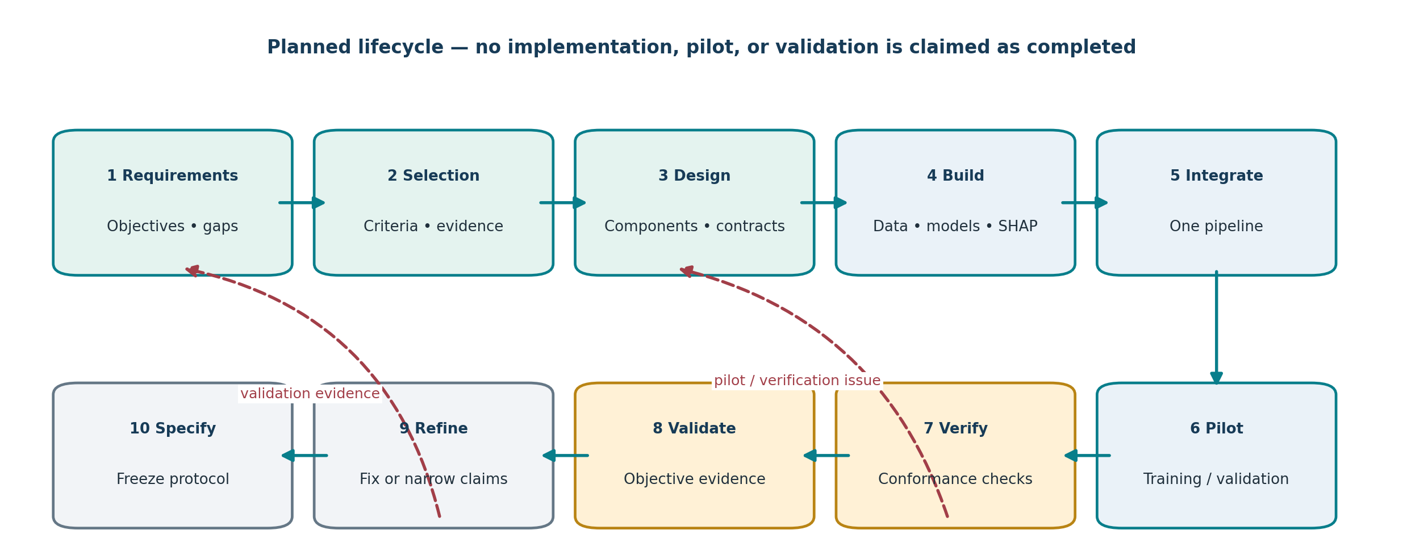
Figure 4:Methodology Design and Development Lifecycle
The lifecycle supports all objectives by making development iterative but protecting the test set. Pilot and verification failures return to component design; validation weaknesses lead to refinement or narrower claims. The diagram describes future work only; no implementation or validation is claimed as complete.

Preliminary Testing or Pilot Evaluation
A pilot is planned, not completed. It will use a small, documented sample from training/validation periods to test ingestion, timestamp alignment, feature eligibility, sequence construction, model execution, SHAP adapter compatibility, and figure/table generation. It will not use 2024 to choose features, thresholds, lookback, hyperparameters, or explainers. The pilot exit criteria are: no unresolved schema/target mismatch; reproducible sample counts; no future-value leakage; acceptable model/explainer runtime; and traceable outputs.

Iterative Refinement
If the pilot reveals inconsistent timestamps, sparse signals, unstable preprocessing, incompatible SHAP support, or inadequate regime-window coverage, the response is to correct the source procedure, reduce the feature set, select a compatible explanation method, merge windows only under a pre-specified coverage rule, or narrow the claim. Each change is logged with its evidence and evaluated on training/validation data. Any protocol change after opening the 2024 test requires disclosure and, if material, a new untouched test period or explicit acknowledgement that the test is no longer independent.

Final Methodology Specification
The final protocol will contain the data manifest, target and input dictionary, availability audit, preprocessing rules, chronological split, turbine-pooling rule, regime cut-points, model configurations, validation selection rules, SHAP explainers/background, aggregation scheme, stability metrics, perturbation design, uncertainty method, software versions, seeds, and reporting templates. These values will be finalized before the held-out year is used for final evaluation.

Data Collection and Preparation

Data Requirements
The core data must provide a timestamped turbine active-power target on a verified 10-minute grid, candidate lagged SCADA predictors, a forecast-time wind-speed signal for regime assignment, and sufficient coverage in each planned test window. Event/status data and official signal mappings are required to interpret shutdowns, warnings, onset, missingness, and units. No final row count or exact signal list is supplied; both remain to be established from the actual files.

Data Sources and Acquisition
Kelmarsh v4 is the primary source: 10-minute SCADA and event records for six Senvion MM92 turbines across 2016–2024 are described in the supplied sources [15], [41]. The Park deposit provides reconstructed 2023–2024 files, a signal-onset manifest, and flags [16]. The analysis should use those reconstructed files or independently reproduce and verify the reconstruction; do not apply a generic “keep last duplicate” rule. Penmanshiel is a conditional secondary site [17]. SDWPF is excluded from the core design because its site/permission context differs and the proposal explicitly removes it from the core [18].

Dataset and Sample Selection Criteria
- Include Kelmarsh turbine-time rows only when the target and required input coverage are valid and the timestamp is unique after documented reconstruction.
- Use the 2017–2022 development period, 2023 validation period, and 2024 final test year specified in the proposal. The 2023 and 2024 inputs must pass the Park reconstruction and signal-onset audit [16].
- Construct sequences separately within each turbine and do not cross missing-data gaps, turbine boundaries, or time partitions.
- Use all eligible observations for core scoring; if SHAP computation requires subsampling, select a deterministic, stratified subset and report its selection rule and coverage.
- Use Penmanshiel only if its feature definitions, units, target and time coverage permit a defensible separate transfer experiment; do not pool with Kelmarsh [17], [19].

Data Collection and Processing Pipeline
Figure 5 presents the data path from acquisition through an integrity gate to the analysis-ready dataset. The gate is consequential: if signal onset, reconstructed timestamps, target units, or feature latency cannot be established, model fitting must pause rather than treat the uncertainty as routine missingness.

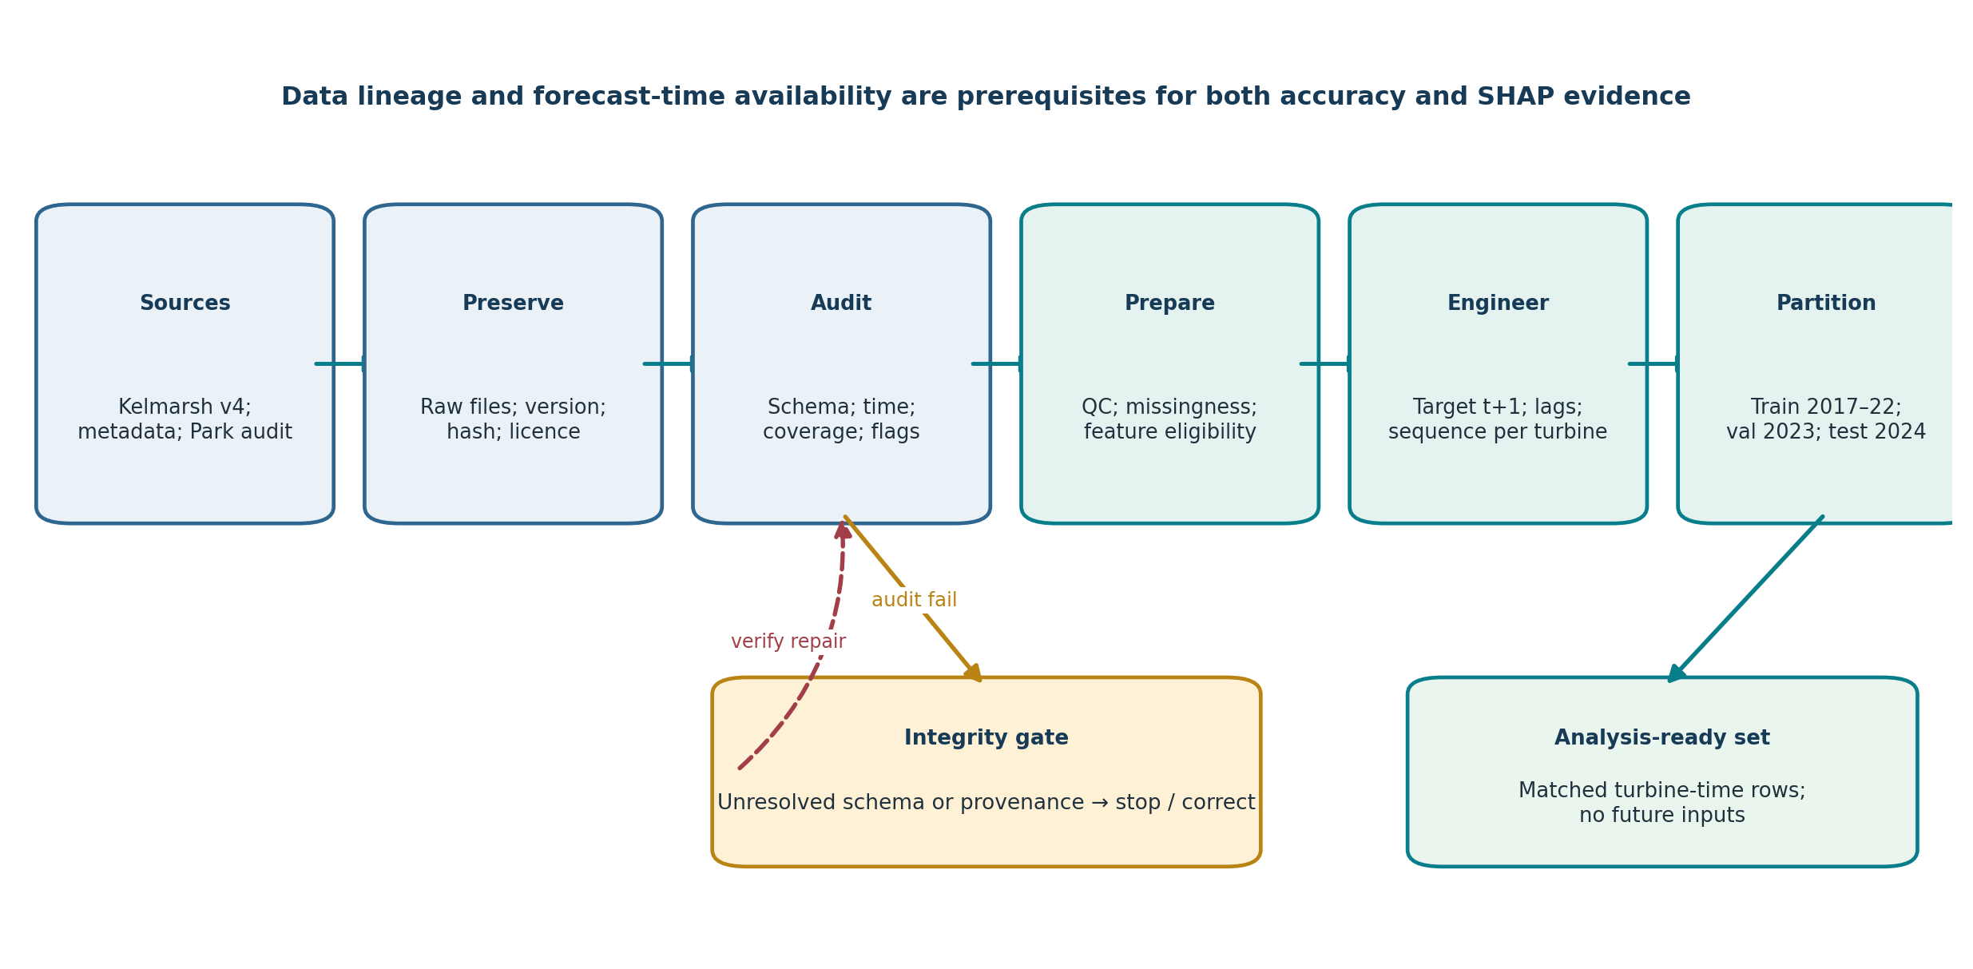
Figure 5:Data Collection and Processing Pipeline.
The pipeline implements O1. It preserves provenance before transforming data, routes unresolved integrity issues back to audit, and emits a time-aligned target with only forecast-time-eligible inputs. Its output is a reproducible row manifest, not an assumed sample size.

Data Quality Assessment
The planned audit checks schema and column meanings; timestamp format, timezone and 10-minute regularity; duplicates and cumulative blocks; signal onset/coverage by turbine and year; missingness and sentinel values; units and plausible ranges; event/status flags; negative or abnormal power; and data-license terms. Every exclusion, reconstruction, conversion, and filter is recorded. Data reports in the project state that the repository files have not yet been opened, so these are planned checks rather than completed findings [41].

Cleaning, Missing Values, and Outliers
A missing target makes a supervised sample unusable and should not be imputed for model scoring. For predictor gaps, first assess whether the signal is absent by design or invalid; drop a feature with inadequate or shifting coverage rather than creating a misleading common input. If imputation is justified, fit the imputer on training data only and use causal, bounded procedures; do not interpolate from future observations. Use event/status information to distinguish faults, curtailment, standby, and normal operation. Negative or extreme values are investigated against signal definitions and context; do not clip them automatically.

Feature Engineering and Selection
Table 8:Candidate data channels and availability controls
Candidate channel / feature | Proposed role | Availability rule | Decision status
Active power history | Primary autoregressive predictor; also target at t+1. | Use only readings recorded and available by issue time; lag to avoid target leakage. | Candidate; exact signal name/unit to verify.
Wind speed / direction | Forecast inputs and regime variable; direction may use circular encoding. | Regime signal must be available at forecast origin; direction encoding is fitted/defined without test information. | Candidate; confirm signal mapping and engineering thresholds.
Rotor/generator speed, pitch, nacelle direction | Turbine-operational covariates. | Use current value only if operationally available by issue time; otherwise lag or exclude. | Candidate, not guaranteed to be present throughout.
Time features | Optional cyclic time-of-day / calendar terms to capture periodicity. | Construct from timestamp available at issue; no future-derived feature. | Proposed; retain only if pre-specified and applied consistently.
Event/status/quality flags | Quality filtering and operating-state context; possible stratification. | Use flags only if meaning and availability are documented; do not use future event outcomes as predictors. | Primarily audit/filter fields; feature use requires justification.
ERA5 or other weather input | Potential future weather information only if operational forecast is available. | ERA5 reanalysis is not an issue-time weather forecast; do not use as future predictor. | Excluded from core unless a genuine forecast product is documented.

Data Transformation and Normalization
Use model-appropriate transformations: scale or normalize features for LR and the LSTM if needed, but do not impose unnecessary scaling on tree splits. Fit all transformations and any feature-selection procedure on the training period, apply unchanged to validation and test, and persist their parameters. Encode wind direction in a circularly appropriate representation where used. Any missingness indicator, feature-group definition, and normalization must be common or explicitly mapped across models for SHAP comparison.

Data Partitioning and Leakage Prevention
Use the source-specified chronological partition: 2017–2022 training, 2023 validation, 2024 final test. At the end of validation, freeze the feature set, lookback, hyperparameters, regime cut-points, background selection, and explanation aggregation. Fit the selected configuration on the specified 2017–2022 training partition and evaluate once on 2024; keep 2023 as validation. No random row split is used. No target-time observation, future SCADA, post-issue event, future-filled missing value, or test-derived normalization may enter a predictor. The exact interpretation of timestamps and data latency is verified before defining t and t+1.

Data Privacy and Management
The sources describe public, secondary turbine data and no personal data or human participants. Preserve immutable raw copies; store checksums, repository versions, licence/attribution, access date, scripts, configuration, derived-data lineage, and exclusion logs. Restrict write access to raw sources and use version-controlled code. Share derived files only after license review; attribute Kelmarsh and Penmanshiel under their stated terms [15], [17]. Follow the university’s data-retention and research-integrity policies.

Proposed Methods, Models, and Techniques

Overview of the Proposed Approach
For turbine j and forecast origin t, estimate the next recorded active power from an ordered history of information that is available at t: ŷ(j,t+1) = f_m(X(j,≤t)), where m ∈ {LR, XGBoost, LSTM} and the sampling interval is 10 minutes. The high-level input features are aligned across models; tabular lag vectors are used for LR/XGBoost and ordered windows for LSTM.

Candidate Methods and Algorithms

Linear Regression baseline
Purpose: Provide a transparent reference for structured lagged features. Its input is a fixed vector of eligible lags and covariates; its output is a point forecast. A basic form is ŷ = β₀ + Σₖ βₖxₖ. It is computationally inexpensive and supports a direct baseline comparison, but can underfit nonlinear power curves and interactions. Coefficients are not interpreted as causal effects, especially with correlated SCADA signals.

XGBoost
Purpose: Model nonlinear relationships and feature interactions in structured SCADA features. A boosted-tree prediction can be represented as ŷ(x) = Σₘ fₘ(x), where each fₘ is a learned tree. It is a suitable tabular comparator and wind-specific applications exist [12], [21]. Its performance depends on hyperparameters, feature availability, and temporal validation; it is not assumed to outperform LR or LSTM.

Long Short-Term Memory
Purpose: Represent sequential dependence in multivariate turbine histories. The input is a sequence of the same high-level variables over a training/validation-selected lookback; the output is the next 10-minute power value. Sequences are built separately within each turbine and never cross gaps or splits. LSTM can model nonlinear temporal structure, but introduces architecture, seed, computation, and explanation-aggregation choices; its benefit must be demonstrated on matched test rows [13], [28], [32].
Table 9:Core model specification
Model | Input representation | Output | Selection / fitting procedure | Principal advantage and limitation
Linear Regression | Fixed vector of forecast-time-available high-level features and lags. | Point forecast of active power at t+1. | Fit on training period; use the same target rows and training-only preprocessing. | Transparent baseline; may underfit nonlinear relationships and interactions.
XGBoost | Structured tabular features with the same high-level inputs/lag map where possible. | Point forecast of active power at t+1. | Select a limited hyperparameter set on 2023 validation data; freeze before 2024. | Models nonlinearities/interactions; tuning and feature correlations affect behavior.
LSTM | Ordered multivariate sequences; sequence is built within turbine and contiguous period. | Point forecast of active power at t+1. | Fit on 2017–2022; choose lookback/architecture using 2023 validation; record seeds and runtime. | Represents sequential dependence; greater computation and explanation-aggregation complexity.

Selection Criteria
The three families are retained because the proposal specifies them and they represent a compact progression from linear reference to boosted trees and sequence learning. The primary selection criterion is not complexity but whether a method can be trained on the approved inputs, evaluated under the same split, explained with a documented SHAP setup, and reproduced with available computation. Other model families are excluded from the core scope.

Justification for the Selected Methods
Recent studies establish active development in boosted, recurrent, convolutional, attention, and hybrid forecasting [1]–[14], [20]–[23]. The selected trio allows a meaningful but feasible comparison without turning the study into an architecture search. The performance result will be local to the selected data, target, horizon, features, and validation design.

Model Architecture and Feature Representation
LR and XGBoost receive fixed tabular vectors containing the allowed high-level variables and lags. LSTM receives ordered sequences of those variables. To support SHAP comparability, lag-level or time-step attributions are aggregated into a pre-specified high-level feature map. A proposed default is to train one pooled site model per family on the six Kelmarsh turbines while keeping turbine ID out of the predictor set and retaining it for grouped reporting; this is an operational recommendation because the proposal specifies the turbine-time unit but not pooled versus per-turbine fitting. Confirm after the pilot; per-turbine models can be a sensitivity if heterogeneity warrants them.

Mathematical Foundations and Operational Measures
Forecast metrics are computed on the same N observations for each model:
 | MAE = (1/N) Σᵢ |yᵢ − ŷᵢ| | (i)
 | RMSE = √[(1/N) Σᵢ (yᵢ − ŷᵢ)²] | (ii)
 | R² = 1 − Σᵢ(yᵢ − ŷᵢ)² / Σᵢ(yᵢ − ȳ)² | (iii)
MAE and RMSE are expressed in the verified target unit; MAE is the average absolute error and RMSE weights larger errors more. R² is supplementary and may be negative on a test sample. MAPE is not a primary metric because zero or near-zero power can make percentage error undefined or misleading; this is also noted in the proposal [11].
For an additive SHAP explanation of a prediction, the local model output is represented as f(x) ≈ φ₀ + Σₖ φₖ. For LSTM, let φ(i,ℓ,f) denote the contribution of feature f at lag/time step ℓ for case i; aggregate to a common feature group using Φ(i,f) = Σℓ φ(i,ℓ,f), and define global importance within regime r and window w as I(f,r,w) = meanᵢ |Φ(i,f)|. This aggregation rule is a proposed operationalization and must be fixed before comparing windows.
For each model and regime, the primary temporal stability statistic is pairwise Spearman correlation between feature-importance rankings from fixed chronological windows. Secondary measures are top-five Jaccard overlap J(A,B)=|A∩B|/|A∪B| and dispersion of normalized feature importance q(f,r,w)=I(f,r,w)/Σg I(g,r,w), summarized continuously across windows. No universal threshold is assumed. Between-regime contrasts are reported separately from within-regime stability.
For RQ5, pair window-level error and stability summaries. An exploratory Spearman association may be reported, with block-based uncertainty; because there are only three model families, a model-level correlation is descriptive, not a general law. A grouped perturbation score can be defined as Δg = mean |f(x)−f(x̃g)|, where x̃g is a plausible, pre-specified conditional replacement for feature group g. Compare highly attributed groups with matched controls; this evaluates model reliance under the perturbation design, not physical causality.

Baseline Methods for Comparison
Linear Regression is the sole core baseline. XGBoost and LSTM are compared against it on identical target rows, horizons, and feature groups. No numerical performance threshold or expected ranking is assumed. Penmanshiel is not a baseline; it is optional external site-transfer evidence, reported separately [17], [19].

Training, Optimization, and Analytical Procedures
- Fit candidate models on 2017–2022; use 2023 to select a limited, documented range of feature/lookback and hyperparameter settings.
- Use early stopping or other regularization decisions only within the development/validation design; do not inspect 2024 while tuning.
- Fit the frozen configuration on the specified 2017–2022 training partition; retain identical 2024 scoring rows across all model families.
- Record stochastic seeds for LSTM and repeat fits under a pre-specified seed set where compute permits; attribute seed variation separately from temporal variation.
- Keep raw predictions, residuals, model artifacts, fitted transformations, config files, package versions, and logs.

Explainability and Interpretability
Generate global mean-absolute SHAP summaries and signed contributions, plus local explanations for a pre-selected set of forecasts that includes each regime and some high-error cases. Candidate explainers are LinearExplainer for LR, TreeExplainer for XGBoost, and a compatible Deep/Gradient or model-agnostic explainer for LSTM. The exact implementation is selected after a training/validation pilot based on compatibility, additivity/output checks, runtime, and a fixed background sample. LSTM time-step contributions are aggregated into the common feature map. Correlated inputs can share or shift attribution [26], [29], [32]; explanations are conditional model attributions, not causal effects.

Expected Outputs
- Forecasts and error tables for LR, XGBoost, and LSTM on common 2024 observations.
- Global and selected local SHAP explanations with feature-map, explainer, background, and seed records.
- Regime- and window-specific rank stability, overlap, dispersion, and uncertainty summaries.
- Perturbation/ablation evidence and a cautious accuracy–stability interpretation.
- Reproducible code, configuration, provenance manifest, reporting tables, and limitations statement.

Computational Architecture and Implementation Design

System Overview
The research requires a computational pipeline, not a deployed application. Figure 6 shows a local, file-based architecture that ingests public data, audits and transforms them, invokes model runners, aligns forecasts, computes SHAP and evaluation measures, and writes versioned outputs. A database, API, user interface, and public deployment are not justified by the proposal and are not included.
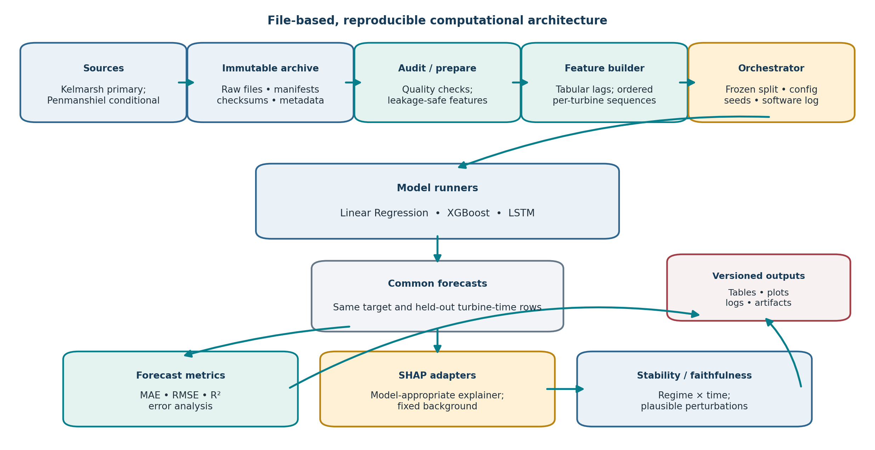
Figure 6:File-Based Computational Architecture
The architecture supports O1–O5 by keeping the raw archive immutable, the configuration explicit, and forecasts and attributions joined on common timestamps. It is a proposed research implementation; the exact package versions, available hardware, and storage capacity must be confirmed during the pilot.

Component and Module Design
- Ingestion/provenance module: Reads source files and metadata; writes a manifest, checksums, and audit logs.
- Quality/feature module: Validates schema and time; applies approved filters, lags, encodings, preprocessing, and partitions.
- Model adapters: Expose a common fit/predict interface for LR, XGBoost, and LSTM while preserving each model’s required representation.
- Explanation adapter: Records explainer, background, high-level feature mapping, output checks, and local/global SHAP results.
- Evaluation module: Computes forecast metrics, regime/window summaries, stability, perturbation, and uncertainty estimates.
- Reporting module: creates tables, plots, configuration summaries, and versioned results. No live service is required.

Data Flow and Processing Architecture
Data flow is one-directional until validation: raw source → immutable archive → audit/preparation → feature/sequence builder → experiment orchestrator → model predictions → metrics and SHAP → stability/faithfulness → versioned report. Identifiers and configuration metadata travel with each output. Optional Penmanshiel data follow a separate branch, not a pooled training table.

Model and Analytical Integration
The orchestrator supplies the frozen split, target definition, feature map, seed set, and model settings. All model outputs are joined to the same eligible final-test row IDs. The SHAP component receives the fitted model, feature representation, and reference sample; LSTM sequence attributions are transformed to the pre-specified high-level feature groups. The evaluation component checks completeness before computing paired summaries.

Storage Design
Use a versioned file structure rather than a database: read-only raw sources; audit/manifests; processed data with lineage; fitted transformations and model artifacts; predictions/residuals; SHAP outputs; metrics; figures; and run logs. A project-specific folder standard and retention policy should be fixed before acquisition. Raw files are never overwritten by reconstructed or cleaned files.

Software and Hardware Requirements
A proposed open-source Python stack is pandas/NumPy for data work, scikit-learn for preprocessing and LR, XGBoost for boosting, a single selected deep-learning library for LSTM, SHAP for attributions, and Matplotlib or equivalent for reports. This stack is a recommendation, not a claim about the researcher’s installed environment. Pin versions and verify supported explainers. A multi-core research workstation is expected; GPU acceleration may help LSTM but is not mandatory. Memory, storage, and any GPU requirement must be set after raw-file size and pilot runtime are measured.

Technology Selection and Justification
A local, scriptable workflow is preferable to web services because the research is retrospective, data are file-based, reproducibility is central, and the proposal specifies no user-facing product. Use widely supported packages, environment files, version control, and deterministic configurations. Avoid adding cloud infrastructure, databases, or APIs without a research need.

Implementation Procedures
Implementation proceeds as modular scripts/notebooks with tested functions:
(1) acquisition and hash;
(2) audit and report;
(3) create target/inputs;
(4) split and fit transformations;
(5) train/validate and freeze models;
(6) final prediction;
(7) SHAP;
(8) stability and perturbation;
(9) export tables, plots, and logs.
Each run should be reconstructable from source version, configuration, software environment, and seed.

Reliability and Deployment Considerations
Reliability is addressed through immutable data, checksums, unit and integration tests, explicit data contracts, saved environments, and repeated-run checks. Security is limited to protecting research files and credentials; no sensitive personal data are expected. There is no deployment step in this study, and operational performance beyond the historical test is not implied.

Experimental Design and Evaluation

Evaluation Objectives
Evaluation answers RQ1–RQ5: quantify 10-minute forecasting error; identify global/local SHAP features; describe attribution differences across wind regimes; measure within-regime temporal stability and repeated-fit sensitivity; and cautiously relate stability to forecast error. The same models, target, eligible observations, and analysis rules are used where possible.

Experimental Design
Figure 7 shows the planned holdout design. The 2017–2022 period is for fitting; 2023 is for model/lookback/threshold and protocol selection; the final 2024 year is reserved for evaluation. After selection, freeze the configuration and fit on the specified 2017–2022 training partition; retain 2023 as validation and 2024 as the final test. This follows the proposal’s stated split and avoids treating validation observations as final-fit training data.
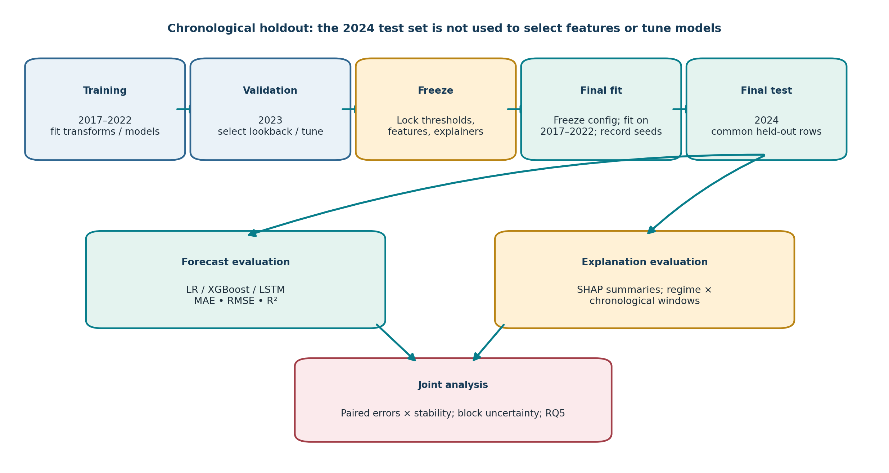
Figure 7:Experimental Design and Evaluation Workflow
The workflow protects the final test from tuning and makes model comparisons paired. Forecast error and SHAP analysis use matched rows; stability is computed across fixed windows within each regime; uncertainty preserves temporal and turbine grouping. Penmanshiel appears only as a conditional, separately reported transfer test.

Experimental Environment
Record operating system, Python and package versions, CPU/GPU availability, memory, run time, data release/version, code commit, and seeds. These details are not supplied in the proposal and must be captured during implementation. Run the core experiment in a reproducible environment with fixed configs; avoid undocumented manual edits.

Evaluation Data and Conditions
The final evaluation uses eligible 2024 Kelmarsh turbine-time rows after the reconstruction/quality gate. Each case is labeled by turbine, timestamp, wind regime, chronological window, and model/seed. Regime cut-points are set using documented turbine power-curve/operating information where available; otherwise derive statistical bands from training-period data and freeze them before test evaluation. If a regime-window cell lacks adequate coverage, report it as insufficient rather than force a conclusion.

Baseline Selection
Linear Regression is the transparent baseline, with XGBoost and LSTM as the selected alternatives. A result is described as better only for a named metric, target, horizon, split, and sample. No model-family result from another farm is used as a numeric benchmark because data and protocols differ [12], [13], [20]–[23].

Evaluation Metrics
Table 10:Evaluation measures and interpretation
Evaluation target | Measure | Operational definition | Use in study | Interpretive limit
Forecast accuracy | MAE | Mean |observed − predicted| over common test rows. | Main error measure; overall, turbine, regime/window when sample allows. | Target units; does not show error tail alone.
Forecast accuracy | RMSE | Square root of mean squared error over same rows. | Co-primary error measure; emphasizes larger errors. | Scale and outliers affect it; pair with MAE.
Forecast accuracy | R² | 1 − residual sum of squares / total sum of squares. | Supplementary fit measure. | Can be negative on test data; not an error-unit measure.
Global explanation | Mean absolute SHAP by feature group | Mean of |aggregated contribution| over selected cases. | RQ2 global ranking; compare regimes/windows. | Dependent on model, feature map, background, correlations.
Local explanation | Per-case signed SHAP | Feature contributions for selected held-out forecasts. | RQ2 local illustrations, including regimes and high errors. | Not causal; selection rule must be stated.
Temporal stability | Pairwise Spearman rank correlation | Rank agreement between window-specific global importances within one regime. | Primary RQ4 stability measure. | Continuous; feature count/ties and sample size affect it.
Temporal stability | Top-five Jaccard overlap | Intersection/union of top-five feature groups between windows. | Secondary stability measure. | Sensitive to cutoff k and near-tied ranks.
Temporal stability | Normalized attribution dispersion | Dispersion across windows of normalized feature-importance vectors. | Secondary magnitude-stability summary. | Operational definition and normalization must be frozen; no universal threshold.
Reliance / faithfulness proxy | Grouped perturbation effect | Prediction change under plausible conditional replacement of a pre-specified feature group. | Limited check for highly attributed versus matched control groups. | Model reliance under the perturbation scheme, not physical causation.
Joint RQ5 | Exploratory error–stability relation | Paired error and stability summaries across model × regime × window. | Describe whether lower error coincides with higher stability. | Only three model families; association is exploratory, not causal or general law.

Validation Procedures
Validation is chronological and objective-linked. The 2023 year supports tuning and freezing; 2024 is the locked final test. All model scores are paired by timestamp. SHAP configuration and feature aggregation are checked on validation samples before final explanation evaluation. If Penmanshiel is feasible, transfer is without retraining/fine-tuning for a genuine site-transfer test; otherwise report it as a separate site-specific experiment, not external validation [17], [19].

Statistical Analysis
Report point estimates and uncertainty. Use paired resampling on common timestamps and block-based bootstrap intervals that preserve temporal dependence; where appropriate, resample turbine groups as clusters. Avoid treating every 10-minute record as independent. For RQ5, show model/regime/window profiles and, if a Spearman association is computed, label it exploratory because only three model families are compared. Report confidence intervals or bootstrap distributions for stability summaries where cell sizes permit.

Robustness and Sensitivity Analysis
- Repeat stochastic LSTM fits with pre-specified seeds when compute allows; quantify seed sensitivity separately.
- Check a reasonable alternative SHAP background/reference sample and report whether the feature ranks change.
- Vary regime boundaries only in a declared sensitivity analysis; do not choose the definition that yields the preferred test result.
- Check the effect of event/status exclusions and feature-coverage rules; retain an audit trail.
- Use plausible grouped perturbations or ablations; avoid zero-masking correlated SCADA channels without justification.
- Optionally test transfer to Penmanshiel, with no pooling and clear same-country/site-generalization limits.

Reproducibility Measures
Archive the source/reconstruction version, hashes, row manifests, feature dictionary, preprocessing fit objects, split boundaries, regime thresholds, model/explainer settings, seed values, software environment, code revision, and output files. Make all stochastic choices explicit. Provide a run script or documented entry point and retain logs for failed runs as well as final runs.

Success Criteria
Success is defined procedurally, not by an invented accuracy or stability threshold:
- The data audit and issue-time eligibility checks pass or limitations are recorded;
- All three models are compared on common eligible 2024 timestamps;
- The five objectives receive corresponding evidence;
- SHAP and stability settings are reproducible and uncertainty is reported;
- The RQ5 relation is interpreted cautiously;
- No result is presented as universal, causal, or a claim of superiority beyond the tested setup. If the audit fails, the correct outcome is to revise or narrow the plan, not to force a result.

Verification, Validation, and Refinement

Verification Strategy
Verification checks whether the pipeline conforms to its specification. Figure 8 distinguishes this from validating whether the design answers the research questions. Planned verification includes schema and unit tests; timestamp uniqueness and frequency checks; target t+1 alignment; no-future-feature tests; sequence boundary checks; training-only transformation tests; identical row-ID checks across models; metric implementation tests; and reproducibility checks for saved configurations and outputs.
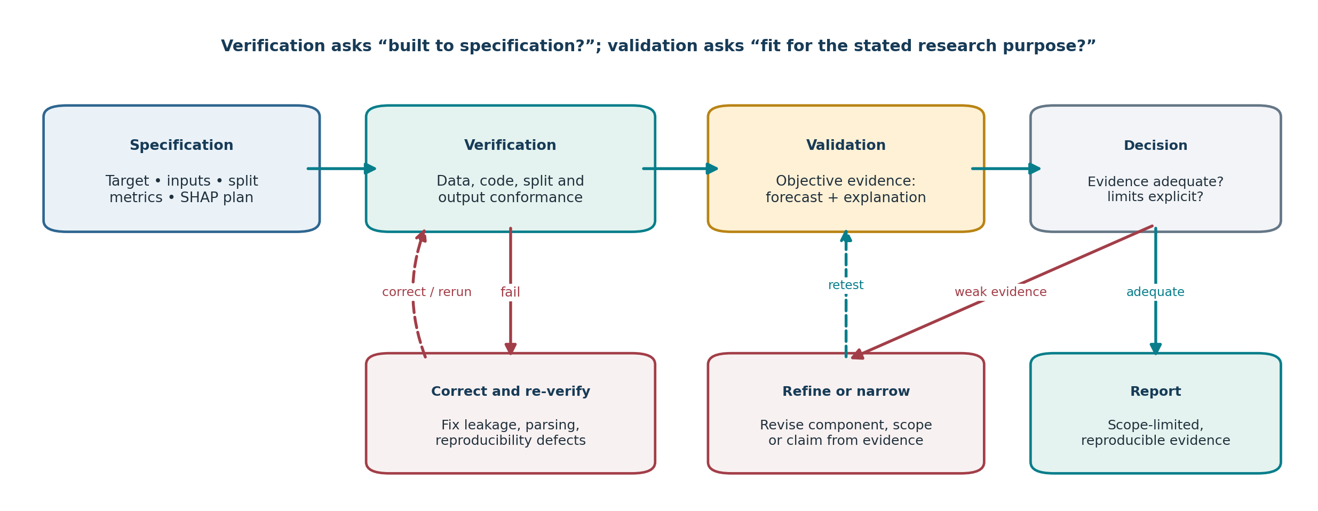
Figure 8:Verification, Validation, and Refinement Framework
Figure 8 separates conformance checks from evidence of research suitability. Verification failures trigger correction and rerunning of checks; weak validation evidence triggers refinement or narrower claims; adequate evidence supports scope-limited reporting. These are planned procedures, not completed tests.

Validation Strategy
Validation asks whether the methodology is suitable for its intended purpose. It uses the held-out chronological test for forecasting, matched observations for SHAP, predefined regime/window comparisons for stability, and objective-level traceability. Penmanshiel may add external site evidence if the source and feature mapping permit it. There is no human-subject validation of user trust, and no physical-causality validation is claimed.

Table 11:Verification and validation evidence plan
Activity | Question answered | Procedure / evidence | Exit condition
Verification | Was the pipeline built to specification? | Schema, timestamp, target, row-ID, leakage, transformation, metric and reproducibility tests. | All required checks pass or are explicitly unresolved and block downstream claims.
Validation | Does the design address the intended objectives? | Common-row forecast metrics; SHAP on matched cases; regime/window stability; objective traceability; optional separate site transfer. | Each objective has evidence or a documented limitation; no unsupported causal/trust claim.
Refinement | What is changed after a weakness is found? | Log defect/evidence; correct code/data contract or narrow feature/scope; rerun verification and relevant validation. | Change is traceable; final test is not represented as untouched if materially reused.

Preliminary Testing or Pilot Studies
A small pipeline pilot on training/validation data is planned to test data ingestion, target alignment, model and SHAP execution, output checks, and runtime. It must not consume the final 2024 test for tuning. No pilot has been performed as part of this report.

Comparison with Existing Approaches
Comparison is internal and controlled: LR, XGBoost, and LSTM on the same target, timestamps, and input availability. Published studies [12], [13], [20]–[23] contextualize method choice but are not treated as external numeric baselines because their datasets and protocols differ. Wind-specific XAI studies [24]–[33] and general time-series methods [34]–[40] contextualize explanation design, not as evidence of expected performance.

Error and Failure Analysis
Inspect residuals by turbine, wind regime, chronological window, and operating/event state; identify missing-target periods, unusual errors, and periods with distribution change. Compare high-error forecasts with their local SHAP summaries without inferring cause. If a model fails on a regime/window, report sample coverage and failure patterns rather than hiding the cell or selecting thresholds post hoc.

Robustness Assessment
Assess robustness to LSTM seeds, alternate plausible SHAP background samples, regime thresholds, and selected preprocessing decisions. Use time-block resampling for uncertainty and a grouped perturbation design for model reliance. The results apply only to the tested choices; robustness checks do not prove future stability.

Identification of Methodological Weaknesses
Weaknesses may arise from incomplete signals, reconstruction uncertainty, sparse regime-window cells, inadequate LSTM explanation support, background sensitivity, unstable feature rankings, or an inability to harmonize Penmanshiel. The researcher will maintain a decision log with evidence, affected objectives, remedy, and residual limitation. A method should not be declared validated solely because all code runs.

Refinement and Improvement Procedures
For implementation defects, correct and re-verify. For weak coverage, simplify the feature set or merge windows only under a rule fixed before final comparison. For SHAP incompatibility, use a documented compatible explainer and report the change. For unstable or contradictory evidence, add sensitivity analysis or narrow the claim. Any material post-test change is disclosed and does not reuse the same test year as if untouched.

Final Validation Criteria
- All five original objectives have auditable output evidence or an explicit limitation explaining why not.
- Forecasts use the correct t+1 target and common, time-valid rows; 2024 was not used for tuning.
- SHAP settings and aggregations are documented; global/local results are linked to the fitted models and reference data.
- Condition dependence, within-regime temporal stability, and fit-seed variation are reported separately.
- RQ5 is framed as exploratory; reliability language is limited to measured repeatability/perturbation evidence.
- The raw source, transformations, code, configuration, and result artifacts support an independent rerun.

Ethical Considerations and Data Management

Ethical Requirements
The study uses public secondary turbine SCADA and related operational data. No human participants, intervention, or personal data are described. The researcher should nevertheless seek or document the university’s ethics/low-risk determination before analysis, following local institutional requirements; this report is not ethics approval.

Privacy and Confidentiality
No direct personal identifiers are expected in the stated data. Check the actual files for incidental names, credentials, or sensitive operational notes before sharing. Keep repository terms and site restrictions visible in the data manifest.

Consent and Permissions
Human consent is not applicable to the planned public-data analysis. Dataset licences, attribution, and any repository conditions remain applicable. Confirm that the exact release and reconstructed files may be used and shared under their stated terms before reproducing or redistributing derived records [15]–[17].

Research Approvals
The researcher should submit the protocol to the relevant Wayamba University research/ethics authority if required and obtain a written exemption or approval decision. Any change to data sources, human involvement, or intended commercial use may require a new determination.

Data Storage and Security
Store raw data read-only with checksums; restrict access to project files; keep a backup in a university-approved location; separate raw, reconstructed, processed, and result files; and avoid storing passwords or tokens in notebooks. Preserve version control for code and run configuration. Retention duration follows institutional policy rather than an assumed period.

Bias, Fairness, and Responsible Use
This is a forecasting and explanation-method study, not a human decision or fairness audit. Potential data bias includes site, turbine, season, operational-state, signal-coverage, and regime imbalance. Report these differences and avoid claims that explanations reveal physical causes or guarantee trustworthy operation. A stable attribution is evidence of repeatability under the selected conditions, not proof of truth.

Data Retention and Sharing
Subject to licensing, the shareable package should include code, manifests, feature definitions, configuration, derived metrics, and report figures. Do not redistribute modified source data without permission. Retain audit logs, code, and thesis/report materials under university policy and cite source datasets [15]–[17].

Expected Outcomes and Research Contributions

Expected Methodological Outcomes
The planned methodological outcomes are an auditable data-preparation protocol, a common time-aware model comparison, documented model-specific SHAP procedures, a regime-by-window stability analysis, and a cautious accuracy–stability synthesis. These are planned deliverables, not completed results.

Expected Technical or Analytical Outcomes
- A versioned data and feature manifest that reports signal coverage, target alignment, and forecast-time availability.
- LR/XGBoost/LSTM model artifacts and common 2024 forecast outputs.
- Global/local SHAP outputs with fixed reference settings and high-level feature aggregation.
- Regime/time-window stability metrics, perturbation checks, and uncertainty summaries.
- Reproducible tables, diagrams, code/configuration, and an explicitly bounded interpretation.

Expected Research Contributions
The contribution is methodological and dataset-specific: an integrated protocol and empirical account of how predictive accuracy and SHAP explanation stability behave for one 10-minute turbine-level comparison under audited data and fixed chronological testing. It is not a new algorithm, a causal explanation method, a universal trust framework, or a verified first claim.

Expected Improvements Over Existing Approaches
The proposed design adds a joint assessment to accuracy-focused comparison and qualitative explanation by linking common-row forecast errors with within-regime temporal attribution stability, while explicitly auditing source integrity and forecast-time availability. It improves the transparency and reproducibility of the evaluation, not necessarily the model’s numerical accuracy.

Contributions to Individual Objectives
Table 12:Objective-specific expected outcomes
Objective | Expected contribution if completed | Evidence required
O1 | Documented, leakage-safe dataset and features. | Audit manifest, coverage table, row IDs, transformation tests.
O2 | Controlled comparison of three specified model families. | Common 2024 metrics and paired error profiles.
O3 | Global/local feature attribution for held-out forecasts. | Explainer/background log, global summaries, selected local cases.
O4 | Quantified regime/time and seed-related explanation variation. | Continuous stability metrics by adequate regime-window cells.
O5 | Balanced synthesis of forecasting error and explanation behaviour. | Paired summaries, uncertainty, cautious RQ5 conclusion.

Potential Practical Applications
The protocol could inform researchers comparing short-term turbine forecasts and assessing whether model-attribution summaries repeat across conditions. It does not itself establish operational readiness, guarantee user trust, or justify control decisions; any such application would require separate prospective and human/operational validation.

Limitations, Risks, and Mitigation

Methodological Limitations
The core design is bounded to one site, one 10-minute horizon, three model families, the selected feature representation, SHAP settings, regime thresholds, and 2024 test year. No universal definition of explanation stability exists. Rank, overlap, and magnitude dispersion capture different properties, and attribution comparisons can be affected by correlated inputs and background selection [26], [29], [35]–[40].

Data or Evidence Limitations
The source documents do not provide the actual downloaded row counts, verified signal list, per-channel missingness, final data unit, or measured regime/window cell sizes. Data integrity, signal onset, repeated blocks, and coverage must be checked from actual files [15], [16], [41]. SCADA may omit physical drivers such as terrain, wake, turbulence, control, or maintenance information. Penmanshiel site transfer, if feasible, does not establish global generalization [17], [19].

Technical Constraints
Repeated LSTM fits and model-agnostic SHAP may be computationally expensive. If full-sample explanation is infeasible, use a pre-specified stratified subset and document its coverage; do not alter analysis samples invisibly.

Resource Constraints
The exact compute environment, storage capacity, and software availability are not specified. Confirm them during the pilot; a GPU is helpful but not assumed. If resources constrain repeated fits or SHAP, prioritize the pre-specified primary measures and report omitted sensitivity analyses.

Potential Sources of Bias
Potential sources include non-random signal availability, missingness related to operating state, regime imbalance, temporal distribution shift, feature correlation, inconsistent turbine coverage, sample selection for local explanations, and the choice of background distribution. These are reported as limitations and tested where feasible; they are not corrected by a single score.

Development and Implementation Risks
Table 13:Risks and mitigation actions
Risk / status | Potential effect | Mitigation / trigger | Residual limitation
Reconstruction or duplicate-timestamp error; source audit flagged this issue. | Invalid target rows, inflated sample counts, misleading metrics and SHAP. | Use reconstructed files or reproduce; compare timestamp counts, values, onset and flags; stop if unresolved. | Reconstruction remains a data provenance dependency.
Signal coverage changes by turbine/year. | Common-feature set shrinks or windows become incomparable. | Build coverage matrix; use consistent intersection for core; report narrowed per-signal tests separately. | May reduce feature richness/sample coverage.
Future-information leakage. | Overstates forecast accuracy and explanation evidence. | Availability audit, causal lags, t+1 alignment tests, no future imputation or ERA5 reanalysis as forecast. | Operational data latency may remain uncertain until documented.
Sparse regime × window cells. | Unstable/undefined rank comparisons. | Set minimum coverage from validation/pilot; report unestimable cells; do not tune cut-offs on test. | Some RQ4 comparisons may remain unavailable.
Correlated predictors/background sensitivity. | SHAP rank shifts without model change. | Fixed background, group features, sensitivity analysis; interpret as conditional model attribution. | Attribution allocation remains assumption-sensitive.
LSTM/SHAP runtime or compatibility. | Incomplete model comparison or explainability. | Pilot on development data; use compatible documented explainer; stratified SHAP subset if needed. | Subset explanations may have sampling uncertainty.
Only three model families for RQ5. | Model-level accuracy–stability correlation is weakly identified. | Report paired profiles and exploratory association only; no general law. | General accuracy–explanation relationship remains open.
Penmanshiel features not harmonizable. | External transfer test infeasible or invalid. | Keep optional; require common feature and target audit; otherwise omit or report separate site study. | Core conclusions remain Kelmarsh-specific.

Risk Mitigation Strategies
Risks are managed through explicit gates, not post-hoc deletion. Stop or narrow the study if source reconstruction cannot be verified, the target cannot be aligned, or forecast-time availability cannot be established. Use validation-only choices, report all exclusions and cell counts, and preserve any failed or alternative run in the log. If an objective cannot be evaluated because a regime/window cell is empty or an explainer is incompatible, state the limitation rather than invent evidence.

Assumptions and Dependencies
- The 10-minute sampling semantics and target timestamp can be verified from dataset documentation.
- The Park reconstruction and manifest can be accessed and matched to the source files.
- At least one forecast-time wind-speed signal and an active-power target are sufficiently available for the core test.
- The research environment can run the three model families and at least one compatible explainer per model.
- University ethics, data-retention, and licence conditions permit the planned secondary analysis.

Work Plan and Resources

Research and Development Activities
The plan is relative because no institutional submission date, semester deadline, or available compute schedule is supplied. A 20-week sequence is proposed, beginning after supervisory approval and repository access. Tasks may overlap only where their dependencies are satisfied.

Development Stages and Milestones
Table 14:Indicative milestones, dependencies, and deliverables
Stage / weeks | Activities | Dependency | Milestone / deliverable | Objectives
Weeks 1–2 | Lock protocol; map proposal RQs/objectives to literature; verify repository records/licence; prepare code environment. | Supervisor/ethics guidance and data access. | Protocol v1, source manifest template, ethics determination request. | All
Weeks 3–4 | Acquire files; reproduce/check Park reconstruction; audit schema, timestamps, units, signal onset, flags, coverage. | Protocol and source access. | Data audit and decision log; pass/stop decision. | O1
Weeks 5–6 | Build LR/XGBoost/LSTM; tune limited settings on 2023; pilot SHAP compatibility and runtime. | Audit passes. | Feature dictionary, split manifest, preprocessing tests. | O1
Weeks 7–9 | Build LR/XGBoost/LSTM; tune limited settings on 2023; pilot SHAP compatibility and runtime. | Analysis-ready train/validation data. | Frozen model/explainer plan and pilot report. | O2–O3
Week 10 | Freeze protocol; fit selected configuration on 2017–2022; open and score 2024 once. | Model and data gates pass. | Final forecast outputs and error table. | O2
Weeks 11–13 | Compute global/local SHAP; regime and chronological window analysis; repeated fits if feasible. | Frozen models and common test rows. | Attributions and stability summaries. | O3–O4
Weeks 14–15 | Perturbation, background/threshold sensitivity, block uncertainty and failure analysis. | Stability outputs. | Robustness and limitations log. | O4–O5
Week 16 | Optional Penmanshiel transfer without retraining if harmonization passes. | Separate data audit; otherwise omit. | Transfer report or justified non-inclusion. | O5
Weeks 17–18 | Verification, independent rerun, refine weak components, finalize objective traceability. | All analytical outputs. | Verified reproducibility package. | O1–O5
Weeks 19–20 | Write, review, correct references/figures, archive code and report. | Final validation and supervisor feedback. | Final thesis/report and reproducibility bundle. | O1–O5

Project Timeline
Figure 9 shows the indicative 20-week sequence. The critical path runs from data integrity through feature preparation, model validation, locked final testing, SHAP/stability analysis, and final verification. Penmanshiel is an optional task and may be dropped without invalidating the core objectives.
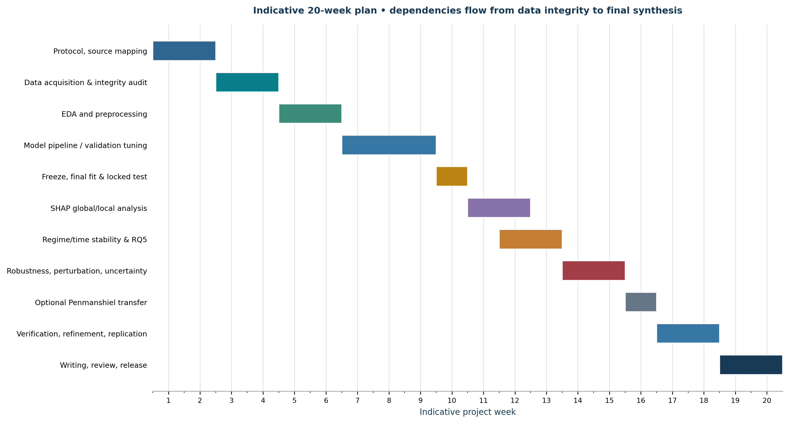
Figure 9:Indicative 20-Week Research Development Timeline
The Gantt chart is a planning estimate, not a committed university calendar. The source/data audit is an early gate; subsequent modeling and stability work depend on valid, reproducible inputs. The optional external-site test is scheduled only after the core protocol is operational.

Hardware and Software Requirements
Required resources are access to the public repositories and documentation, a version-controlled analysis environment, sufficient local or university storage for raw and derived files, and a workstation capable of the planned LSTM and SHAP pilot. Exact specifications cannot be responsibly fixed before the data are downloaded and runtime measured. A GPU is useful but not assumed. The proposed stack is Python, pandas/NumPy, scikit-learn, XGBoost, one deep-learning framework, SHAP, and plotting libraries; versions must be pinned.

Personnel and Expertise
The primary researcher performs the data audit, modeling, analysis, and reporting. Supervisor review is needed for the target/split, domain-specific regime thresholds, ethics determination, and final interpretation. No additional personnel requirement is established in the source documents.

Budget
No budget or paid-service requirement is specified. Public datasets and open-source software are intended to minimize direct costs. Any hardware purchase, cloud compute, travel, or data access fee should be added only after confirming availability and institutional resources; no monetary estimate is fabricated here.

Expected Deliverables
- Approved, versioned experimental protocol and source-data manifest.
- Audited, leakage-safe preprocessing and feature pipeline with tests.
- LR/XGBoost/LSTM model artifacts, common 2024 predictions, and error analysis.
- Documented global/local SHAP outputs and stability/faithfulness summaries.
- Optional, separately reported Penmanshiel transfer analysis if justified.
- Final methodology report, figures, tables, code, environment file, logs, and data-management record.

Conclusion
This report has translated the supplied wind-power proposal and literature review into a research-specific methodology for 10-minute-ahead turbine active-power forecasting and SHAP stability evaluation. The design preserves the proposal’s five objectives and five questions, uses Kelmarsh as the audited primary data source, compares LR, XGBoost, and LSTM under a chronological 2017–2022 / 2023 / 2024 design, and treats Penmanshiel as optional separate transfer evidence.
The methodology integrates provenance and forecast-time availability checks with common-row model evaluation, model-appropriate global/local SHAP, within-regime time-window stability metrics, seed sensitivity, plausible perturbation checks, and cautious accuracy–stability synthesis. Verification is distinguished from validation and refinement; all planned work is labeled as planned, and no empirical findings are claimed. Exact signals, cut-points, lookback, explainer settings, pooling decision, and resource requirements remain to be finalized after the raw data and pilot are inspected.
The expected contribution is an auditable, dataset-specific empirical protocol and evidence base. It is not a new forecasting architecture, a causal account of turbine physics, a universal explanation-reliability guarantee, or an unsupported novelty claim. The methodological design is feasible subject to the provenance gate, compute check, and institutional approval described above.

References
[1] Z. Wu, G. Luo, Z. Yang, Y. Guo, K. Li, and Y. Xue, “A comprehensive review on deep learning approaches in wind forecasting applications,” CAAI Trans. Intell. Technol., vol. 7, no. 2, pp. 129–143, 2022, doi: 10.1049/cit2.12076.
[2] M. Sawant, R. Patil, T. Shikhare, S. Nagle, S. Chavan, S. Negi, and N. D. Bokde, “A selective review on recent advancements in long, short and ultra-short-term wind power prediction,” Energies, vol. 15, no. 21, Art. no. 8107, 2022, doi: 10.3390/en15218107.
[3] Y. Chen, X. Hu, and L. Zhang, “A review of ultra-short-term forecasting of wind power based on data decomposition-forecasting technology combination model,” Energy Rep., vol. 8, pp. 14200–14219, 2022, doi: 10.1016/j.egyr.2022.10.342.
[4] Y. Liu, Y. Wang, Q. Wang, K. Zhang, W. Qiang, and Q.-H. Wen, “Recent advances in data-driven prediction for wind power,” Front. Energy Res., vol. 11, Art. no. 1204343, 2023, doi: 10.3389/fenrg.2023.1204343.
[5] E. A. Tuncar, Ş. Sağlam, and B. Oral, “A review of short-term wind power generation forecasting methods in recent technological trends,” Energy Rep., vol. 12, pp. 197–209, 2024, doi: 10.1016/j.egyr.2024.06.006.
[6] Y. Yang, H. Lou, J. Wu, S. Zhang, and S. Gao, “A survey on wind power forecasting with machine learning approaches,” Neural Comput. Appl., vol. 36, pp. 12753–12773, 2024, doi: 10.1007/s00521-024-09923-4.
[7] H. Liu and Z. Zhang, “Development and trending of deep learning methods for wind power predictions,” Artif. Intell. Rev., vol. 57, no. 5, Art. no. 112, 2024, doi: 10.1007/s10462-024-10728-z.
[8] X. Guo, P. Zeng, X. Xiong, G. Wang, and Y. Cui, “Short-term wind power forecasting methods based on machine learning: A review and case study,” Energy Rep., vol. 14, pp. 3753–3782, 2025, doi: 10.1016/j.egyr.2025.10.040.
[9] I. U. Haq, A. Kumar, and P. S. Rathore, “Machine learning approaches for wind power forecasting: A comprehensive review,” Discov. Appl. Sci., vol. 7, Art. no. 1139, 2025, doi: 10.1007/s42452-025-07675-x.
[10] F. Li, H. Wang, D. Wang, D. Liu, and K. Sun, “A review of wind power prediction methods based on multi-time scales,” Energies, vol. 18, no. 7, Art. no. 1713, 2025, doi: 10.3390/en18071713.
[11] P. Piotrowski, I. Rutyna, D. Baczyński, and M. Kopyt, “Evaluation metrics for wind power forecasts: A comprehensive review and statistical analysis of errors,” Energies, vol. 15, no. 24, Art. no. 9657, 2022, doi: 10.3390/en15249657.
[12] X. Xiong, X. Guo, P. Zeng, R. Zou, and X. Wang, “A short-term wind power forecast method via XGBoost hyper-parameters optimization,” Front. Energy Res., vol. 10, Art. no. 905155, 2022, doi: 10.3389/fenrg.2022.905155.
[13] Z. Li, X. Luo, M. Liu, X. Cao, S. Du, and H. Sun, “Short-term prediction of the power of a new wind turbine based on IAO-LSTM,” Energy Rep., vol. 8, pp. 9025–9037, 2022, doi: 10.1016/j.egyr.2022.07.030.
[14] Y. Sheng, H. Wang, J. Yan, Y. Liu, and S. Han, “Short-term wind power prediction method based on deep clustering-improved temporal convolutional network,” Energy Rep., vol. 9, pp. 2118–2129, 2023, doi: 10.1016/j.egyr.2023.01.015.
[15] C. Plumley and R. Takeuchi, “Kelmarsh wind farm data (Version 4),” Zenodo, Aug. 12, 2025, doi: 10.5281/zenodo.16807551.
[16] A. Park, L. Yin, C. Lee, A. Wong, and Y. Choi, “Kelmarsh wind farm SCADA data (v4): Reconstructed 2023–2024 files, signal onset manifest and flag table,” Zenodo, Oct. 5, 2026, doi: 10.5281/zenodo.23171808.
[17] C. Plumley and R. Takeuchi, “Penmanshiel wind farm data (Version 3),” Zenodo, Aug. 13, 2025, doi: 10.5281/zenodo.16807304.
[18] J. Zhou, X. Lu, Y. Xiao, J. Tang, J. Su, Y. Li, J. Liu, J. Lyu, Y. Ma, and D. Dou, “SDWPF: A dataset for spatial dynamic wind power forecasting over a large turbine array,” Sci. Data, vol. 11, Art. no. 649, 2024, doi: 10.1038/s41597-024-03427-5.
[19] C. Deignan, J. M. González Sopeña, B. Ghosh, and V. Pakrashi, “Portability of short term wind power forecasting: Investigating model calibration using wind power data from Ireland and UK,” Sci. Rep., vol. 15, Art. no. 33891, 2025, doi: 10.1038/s41598-025-08751-3.
[20] S. Huang, C. Yan, and Y. Qu, “Deep learning model-transformer based wind power forecasting approach,” Front. Energy Res., vol. 10, Art. no. 1055683, 2023, doi: 10.3389/fenrg.2022.1055683.
[21] U. Ahmed, R. Muhammad, S. S. Abbas, I. Aziz, and A. Mahmood, “Short-term wind power forecasting using integrated boosting approach,” Front. Energy Res., vol. 12, Art. no. 1401978, 2024, doi: 10.3389/fenrg.2024.1401978.
[22] Z. Xin, X. Liu, H. Zhang, Q. Wang, Z. An, and H. Liu, “An enhanced feature extraction based long short-term memory neural network for wind power forecasting via considering the missing data reconstruction,” Energy Rep., vol. 11, pp. 97–114, 2024, doi: 10.1016/j.egyr.2023.11.040.
[23] E. Demir and S. Akkaya Oy, “Short-term wind power forecasting with lag-based feature engineering: A turbine-level machine learning comparison,” Neural Comput. Appl., vol. 38, Art. no. 613, 2026, doi: 10.1007/s00521-026-12356-w.
[24] C. Cakiroglu, S. Demir, M. H. Ozdemir, B. L. Aylak, G. Sariisik, and L. Abualigah, “Data-driven interpretable ensemble learning methods for the prediction of wind turbine power incorporating SHAP analysis,” Expert Syst. Appl., vol. 237, Art. no. 121464, 2024, doi: 10.1016/j.eswa.2023.121464.
[25] D.-Y. Kim and B.-S. Kim, “Contribution of meteorological factors based on explainable artificial intelligence in predicting wind farm power production using machine learning algorithms,” J. Renewable Sustainable Energy, vol. 15, no. 1, Art. no. 013307, 2023, doi: 10.1063/5.0127519.
[26] W. Liao, J. Fang, L. Ye, B. Bak-Jensen, Z. Yang, and F. Porté-Agel, “Can we trust explainable artificial intelligence in wind power forecasting?,” Appl. Energy, vol. 376, Art. no. 124273, 2024, doi: 10.1016/j.apenergy.2024.124273.
[27] W. Liao, J. Fang, B. Bak-Jensen, G. Ruan, Z. Yang, and F. Porté-Agel, “Explainable modeling for wind power forecasting: A glass-box model with high accuracy,” Int. J. Electr. Power Energy Syst., vol. 167, Art. no. 110643, 2025, doi: 10.1016/j.ijepes.2025.110643.
[28] M. A. Yassen, E.-S. M. El-Kenawy, M. G. Abdel-Fattah, I. Ismail, and H. E.-D. S. Mostafa, “Explainable artificial intelligence for wind power forecasting model based on long short-term memory,” Neural Comput. Appl., vol. 37, pp. 14589–14611, 2025, doi: 10.1007/s00521-025-11230-5.
[29] J. T. Dandamudi, R. Kandula, R. D. A. Raj, R. M. R. Yanamala, and K. K. Prakasha, “Explainable AI for wind energy systems: State-of-the-art techniques, challenges, and future directions,” Energy Convers. Manage.: X, vol. 28, Art. no. 101277, 2025, doi: 10.1016/j.ecmx.2025.101277.
[30] P. V. Matrenin, I. F. Iumanova, and A. I. Khalyasmaa, “Conceptual architecture of a trustworthy wind and photovoltaic power forecasting system: A systematic review and design,” Inventions, vol. 11, no. 1, Art. no. 15, 2026, doi: 10.3390/inventions11010015.
[31] V. S. Masampally, R. Verma, and K. Mitra, “Application of TimeSHAP, an explainable AI tool, for interpreting time-series model of wind turbines,” in Optimization, Uncertainty and Machine Learning in Wind Energy Conversion Systems, K. Mitra, R. Everson, and J. Fieldsend, Eds. Singapore: Springer, 2025, pp. 243–266, doi: 10.1007/978-981-97-7909-3_14.
[32] E. Kandemir, D. K. Prasad, A. Hasan, T. Kvamsdal, and S. Abdel-Afou Alaliyat, “Explainable deep learning with Shapley additive explanations for multivariate wind power forecasting,” Energy Convers. Manage.: X, vol. 30, Art. no. 101901, 2026, doi: 10.1016/j.ecmx.2026.101901.
[33] A. Gijón, S. Eiraudo, A. Manjavacas, D. S. Schiera, M. Molina-Solana, and J. Gómez-Romero, “Integrating physics and data-driven approaches: An explainable and uncertainty-aware hybrid model for wind turbine power prediction,” Comput. Phys. Commun., vol. 316, Art. no. 109761, 2025, doi: 10.1016/j.cpc.2025.109761.
[34] A. Theissler, F. Spinnato, U. Schlegel, and R. Guidotti, “Explainable AI for time series classification: A review, taxonomy and research directions,” IEEE Access, vol. 10, pp. 100700–100724, 2022, doi: 10.1109/ACCESS.2022.3207765.
[35] M. Nauta, J. Trienes, S. Pathak, E. Nguyen, M. Peters, Y. Schmitt, J. Schlötterer, M. van Keulen, and C. Seifert, “From anecdotal evidence to quantitative evaluation methods: A systematic review on evaluating explainable AI,” ACM Comput. Surv., vol. 55, no. 13s, Art. no. 295, 2023, doi: 10.1145/3583558.
[36] Y. Gan, Y. Mao, X. Zhang, S. Ji, Y. Pu, M. Han, J. Yin, and T. Wang, “Is your explanation stable?: A robustness evaluation framework for feature attribution,” in Proc. ACM SIGSAC Conf. Comput. Commun. Secur. (CCS), Los Angeles, CA, USA, 2022, pp. 1157–1171, doi: 10.1145/3548606.3559392.
[37] G. Kelodjou, L. Rozé, V. Masson, L. Galárraga, R. Gaudel, M. Tchuente, and A. Termier, “Shaping up SHAP: Enhancing stability through layer-wise neighbor selection,” in Proc. AAAI Conf. Artif. Intell., vol. 38, no. 12, 2024, pp. 13094–13103, doi: 10.1609/aaai.v38i12.29208.
[38] A. Nayebi, S. Tipirneni, C. K. Reddy, B. Foreman, and V. Subbian, “WindowSHAP: An efficient framework for explaining time-series classifiers based on Shapley values,” J. Biomed. Inform., vol. 144, Art. no. 104438, 2023, doi: 10.1016/j.jbi.2023.104438.
[39] D. I. Serramazza, T. L. Nguyen, and G. Ifrim, “Improving the evaluation and actionability of explanation methods for multivariate time series classification,” in Machine Learning and Knowledge Discovery in Databases: Research Track. ECML PKDD 2024, Lecture Notes in Computer Science, vol. 14944. Cham, Switzerland: Springer, 2024, pp. 177–195, doi: 10.1007/978-3-031-70359-1_11.
[40] H. Meng, C. Wagner, and I. Triguero, “Explaining time series classifiers through meaningful perturbation and optimisation,” Inf. Sci., vol. 645, Art. no. 119334, 2023, doi: 10.1016/j.ins.2023.119334.

